VIDHYADEEP INSTITUTE OF COMPUTER & INFORMATION TECHNOLOGY,ANITA-KIM.



**VEER NARAMD SOUTH GUJARAT UNIVERSITY**

**PROJECT REPORT**

**ON**

**“Black Ai”**

**AS A PARTIAL REQUIREMENT FOR THE DEGREE**

**OF**

**BECHOLOR OF COMPUTER APPLICATION ( BCA) Academic Year 2023-2024**

**(TYBCA 6th Semester)**

Internal Guide:- Submitted By:-

Mr.Partik Patel Sunny Javiya

En-roll :- 0043

Harshal Jariwala En-roll :- 0042

 

**VIDHYADEEP INSTITUTE OF COMPUTER & INFORMATION TECHNOLOGY**

# CERTIFICATE

This is to certify that project report,submitted for the project entitled “**Black Ai”** has been carried out by **“Sunny Javiya ,** **Harshal Jariwala”** at BCA department of vidhyadeep institute of computer & information technology, kim for partial fulfilment of BCA degree to be awarded by veer narmad south Gujarat university. this project work has been carried out under my supervision and is to my satisfaction.

Place :- Anita-Kim

Date :- 06/4/2024

**Internal Guide I/C Principal**

MR. Partik Patel Dr..Himansu Patel

**ACKNOWLEDGEMENT**

There are numerous persons to whom we owe our thanks for their help, support, advice and suggestions during the various stages of this project.

At the outset we thank our project external director, ,

Team Leader for her invaluable guidance and supervision for our project in PHP and making it completed within the time frame.

My sincere thanks to **MR. PRARIK PATEL,** who has allowed us to do this project and encouragement given to us.

We are also deeply thankful to our guide , whose useful suggestion

and gentle soothing attitude helped us a lot to learn in this project and also for her constant support throughout the project.

Last but not the least; we extend our sincere thanks to our college staff members and our company/college for their constant support, guidance, encouragement and sustained motivation throughout this project. Also, we would like to extend our profound thanks to all our colleagues and

friends at college level who helped us in the specific areas of this project.

## Thanking You,

**Sunny Javiya Kamlesh Bhai**

**Harshal Jariwala Hitesh Bhai**

Complete Task :-

|  |  |  |
| --- | --- | --- |
| **SR. NO** | **CONTANT** | **PAGE NO.** |
| **1.** | **INTRODUCTION** |  |
| **2.** | **PROJECT PROFILE** |  |
| **3.** | **OBJECTIVES** |  |
| **4.** | **PROJECT CATEGORY** |  |
| **5.** | **ANALYSIS REPORT**   1. **HARDWARE /SOFTWARE ENVIROMENT** 2. **EXISTING SYSTEM** 3. **PROPOSED SYSTEM** 4. **NEED OF THE SYSTEM** 5. **METHODS & TECHNOLOGIES** 6. **LIMITATION OF CURRENT SYSTEM** 7. **REQUIREMENT SPECIFICATION** 8. **DATA FLOW DIAGRAM** 9. **PROCESS SPECIFICATION** 10. **TABLE STRUCTURES WITH RELATIONSHIP** |  |
| **6.** | **DESIGN REPORT** |  |
| **7.** | **TESTING REPORT** |  |
| **8.** | **FUTURE ENHANCEMENT** |  |
| **9.** | **Software Testing** |  |
| **10.** | **REFERENCES** |  |

Internal Guide Signatur

1. **INTRODUCTION**

In an era defined by technological innovation and digital transformation, the integration of Artificial Intelligence (AI) has emerged as a cornerstone of progress across diverse domains. From streamlining processes to enhancing decision-making capabilities, AI technologies continue to reshape industries and revolutionize the way we interact with information and systems.

The advent of AI has spurred the development of sophisticated systems designed to mimic human intelligence, enabling machines to perceive, reason, and learn from data. Among these advancements, the concept of a Black AI system stands out as a cutting-edge solution tailored to meet the evolving needs of users in various contexts.

A Black AI system represents the culmination of years of research and development in AI technologies, leveraging advanced algorithms, data analytics, and natural language processing to facilitate seamless interactions between humans and machines. Unlike traditional AI systems, which may exhibit limitations in understanding complex queries or providing accurate responses, the Black AI system is engineered to transcend these constraints, offering unparalleled capabilities in information retrieval, analysis, and decision support.

At its core, the Black AI system embodies the essence of innovation, pushing the boundaries of what is possible in the realm of artificial intelligence. By harnessing the power of machine learning and cognitive computing, it empowers users to access a wealth of knowledge, derive actionable insights, and make informed decisions with confidence.

Through this document, we embark on a journey to explore the intricacies of the Black AI system, delving into its architecture, functionalities, and real-world applications. From its inception to its implementation, we delve into the underlying principles that drive its operation and the transformative impact it holds for individuals and organizations alike.

As we navigate through the various facets of the Black AI system, we invite you to envision a future where AI transcends mere automation and becomes a trusted ally in our quest for knowledge, innovation, and progress. Together, let us unlock the full potential of artificial intelligence and pave the way for a smarter, more connected world

**2. PROJECT PROFILE**

In an ever-evolving digital landscape, the development of the Black AI system represents a pioneering endeavor aimed at harnessing the transformative potential of artificial intelligence. Rooted in the convergence of cutting-edge technologies and innovative methodologies, this project seeks to redefine the boundaries of AI applications and pave the way for a new era of intelligent systems.

**Key Features:**

* **Advanced Natural Language Processing (NLP):** Leveraging state-of-the-art NLP algorithms, the Black AI system possesses the ability to understand and interpret human language with remarkable accuracy and precision. This enables seamless communication between users and the system, facilitating intuitive interactions and enhancing user experience.
* **Intelligent Data Analysis:** Equipped with sophisticated data analytics capabilities, the Black AI system is capable of processing vast amounts of data in real-time, extracting valuable insights, and generating actionable recommendations. Whether it's identifying trends, patterns, or anomalies, the system empowers users to make informed decisions based on data-driven insights.
* **Interactive Decision Support:** With its decision support functionalities, the Black AI system serves as a trusted advisor, providing users with timely recommendations and guidance to facilitate decision-making processes. By leveraging advanced algorithms and predictive modeling techniques, the system assists users in evaluating various scenarios, assessing risks, and identifying optimal courses of action.
* **Personalized User Experience:** Recognizing the diverse needs and preferences of users, the Black AI system offers a personalized user experience tailored to individual requirements. Through adaptive learning mechanisms, the system continuously refines its understanding of user preferences, behaviors, and interactions, thereby enhancing engagement and satisfaction.

**Target Audience:**

The Black AI system is designed to cater to a broad spectrum of users spanning different industries, sectors, and roles. From business professionals and researchers to educators and policymakers, the system addresses the needs of diverse stakeholders seeking to leverage AI technologies for enhanced productivity, innovation, and decision-making.

**Project Goals:**

* Develop a scalable and robust AI system capable of handling complex tasks and processing large volumes of data.
* Enhance user experience through intuitive interfaces, personalized recommendations, and seamless interactions.
* Foster innovation and creativity by providing users with access to advanced tools and functionalities for data analysis and decision support.
* Establish the Black AI system as a trusted resource and indispensable ally in the pursuit of knowledge, productivity, and excellence.

**Project Timeline:**

The development of the Black AI system follows a structured timeline encompassing various phases, including research, design, development, testing, and deployment. By adhering to a systematic approach, the project aims to ensure the timely delivery of high-quality solutions that meet the evolving needs of users and stakeholders.

**Conclusion:**

In summary, the Black AI project represents a bold initiative aimed at harnessing the power of artificial intelligence to drive innovation, facilitate decision-making, and empower users in their quest for knowledge and excellence. With its advanced capabilities and user-centric design, the system holds the potential to transform industries, revolutionize workflows, and unlock new opportunities for growth and development.

|  |
| --- |
| **PROJECT PROFILE** |
| **Project Title:** Black AI **Project Duration:** Academic Duration Of BCA Sem – 6 **Team Size:** 2 **Front End:** React **Back End:** Python **Database:** MongoDB **Developed By:** Sunny Javaiya, Harshal Jariwala **Internal Guide**: MR. PRARIK PATEL |

**3. OBJECTIVES**

The objectives of the Black AI project are as follows:

1. **Develop Advanced AI Capabilities:** Implement state-of-the-art artificial intelligence algorithms and techniques to enhance the system's ability to understand and process complex queries and data.
2. **Facilitate Seamless User Interaction:** Create intuitive user interfaces and interactive features that enable users to communicate with the Black AI system effortlessly, fostering a seamless and engaging user experience.
3. **Enhance Data Analysis and Decision Support:** Utilize advanced data analytics tools and decision support systems to provide users with actionable insights and recommendations based on real-time data analysis and predictive modeling.
4. **Ensure Scalability and Robustness:** Design the Black AI system to be scalable and robust, capable of handling large volumes of data and accommodating future expansion and growth.
5. **Enable Personalized User Experience:** Implement adaptive learning mechanisms and personalized recommendations to tailor the user experience based on individual preferences, behaviors, and interactions.
6. **Promote Innovation and Creativity:** Provide users with access to advanced tools and functionalities that stimulate innovation, creativity, and problem-solving, empowering them to explore new ideas and solutions.
7. **Improve Efficiency and Productivity:** Streamline workflows and automate repetitive tasks through AI-driven automation, enabling users to focus on high-value activities and achieve greater efficiency and productivity.
8. **Ensure Reliability and Accuracy:** Employ rigorous testing and validation processes to ensure the reliability and accuracy of the Black AI system, minimizing errors and ensuring consistency in performance.
9. **Support Collaborative Decision-Making:** Enable collaborative decision-making by facilitating communication and information sharing among users, teams, and stakeholders through the Black AI platform.
10. **Drive Business Value and Impact:** Deliver tangible business value and impact by providing users with actionable insights, strategic recommendations, and innovative solutions that drive growth, efficiency, and competitive advantage.

**PROJECT CATEGORY**

The Black AI project is a groundbreaking initiative aimed at revolutionizing the landscape of artificial intelligence systems. By harnessing cutting-edge technologies and innovative methodologies, this project endeavors to address the limitations of existing AI systems and unlock new possibilities for intelligent decision support and data analysis.

**About Project:**

The Black AI project is developed to overcome the challenges inherent in traditional AI systems. By leveraging advanced algorithms and intuitive interfaces, this software aims to streamline processes, enhance user experiences, and facilitate seamless interactions between humans and machines. Designed to meet the evolving needs of users across various domains, the Black AI system promises to deliver unparalleled capabilities in information retrieval, analysis, and decision support.

**What We Do?**

We specialize in developing advanced AI solutions tailored to the unique requirements of users and organizations. Our focus is on harnessing the power of artificial intelligence to drive innovation, productivity, and growth. With a dedicated team of experts and a passion for excellence, we are committed to delivering cutting-edge AI technologies that transform industries, empower users, and shape the future of intelligent systems.

**Services We Provide:**

* **Advanced Data Analysis:** Leveraging state-of-the-art algorithms and techniques to extract insights from complex datasets.
* **Interactive Decision Support:** Providing users with actionable recommendations and guidance to facilitate informed decision-making.
* **Personalized User Experience:** Tailoring the user experience based on individual preferences, behaviors, and interactions.
* **Real-time Information Retrieval:** Offering instant access to relevant information and resources to support user needs and objectives.
* **Continuous Learning and Improvement:** Incorporating feedback mechanisms and iterative development processes to enhance system performance and capabilities over time.
* **Ethical Considerations:** Ensuring fairness, transparency, and accountability in the design, development, and deployment of AI technologies.

By offering a comprehensive suite of services and solutions, we strive to empower users with the tools and resources they need to succeed in an increasingly complex and dynamic environment.

**5. ANALYSIS REPORT**

The analysis report for the Black AI project encompasses various aspects, including the hardware/software environment, existing system analysis, proposed system analysis, the need for the system, methods & technologies, limitations of the current system, requirement specification, data flow diagram, process specification, and table structures with relationships.

**1. HARDWARE/SOFTWARE ENVIRONMENT**

The Black AI system requires a robust hardware infrastructure capable of handling complex computational tasks. Software components include AI algorithms, database management systems, and user interfaces. The recommended hardware setup includes high-performance servers with ample processing power and memory, while the software environment comprises Python for backend development, React for frontend development, and MongoDB for data storage.

**HARDWARE ENVIRONMENT**

| **NAME** | **DETAILS** |
| --- | --- |
| Processor | Intel(R) 3.50 GHz |
| Memory | 8.00GB |
| Storage | 1TB |

**SOFTWARE ENVIRONMENT**

| **NAME** | **DETAILS** |
| --- | --- |
| Operating System | Windows |
| Server | Mongo db Server |
| Web Browser | Chrome |
| Version Control System | Git |
| Package Manager | Composer |
| Integrated Development Environment (IDE) | Vs Code |

**EXISTING SYSTEM**

The existing AI systems in use today exhibit several limitations that hinder their effectiveness and usability. These systems typically rely on outdated algorithms and methodologies, resulting in suboptimal performance and user experience. Key limitations of the existing AI systems include:

1. **Limited Natural Language Understanding:** Many existing AI systems struggle to comprehend and process natural language queries accurately. As a result, users often encounter difficulties in communicating their requests effectively, leading to frustration and inefficiency.
2. **Inadequate Data Analysis Capabilities:** Existing AI systems may lack sophisticated data analysis capabilities, making it challenging to derive meaningful insights from large and complex datasets. This limitation hampers decision-making processes and limits the system's utility in real-world applications.
3. **Poor User Interfaces:** The user interfaces of existing AI systems are often cumbersome and unintuitive, requiring users to navigate through multiple menus and options to perform simple tasks. This complexity can discourage users from utilizing the system to its full potential and may lead to reduced adoption rates.
4. **Limited Scalability:** Many existing AI systems struggle to scale effectively to accommodate growing volumes of data and increasing user demands. This limitation can impede system performance and hinder its ability to support the evolving needs of users and organizations.
5. **Lack of Personalization:** Existing AI systems may not offer personalized experiences tailored to individual user preferences and requirements. This lack of personalization can result in generic recommendations and responses that fail to meet the unique needs of users.

Overall, the existing AI systems fall short in meeting the demands of modern users and organizations, highlighting the need for innovative solutions that address these limitations and deliver enhanced performance, usability, and scalability.

**PROPOSED SYSTEM**

The proposed Black AI system aims to overcome the limitations of existing AI systems by introducing advanced algorithms, enhanced user interfaces, and personalized experiences. Key features and enhancements of the proposed system include:

1. **Advanced Natural Language Processing (NLP):** The Black AI system will leverage state-of-the-art NLP algorithms to improve its understanding and interpretation of natural language queries. By enhancing its language processing capabilities, the system will be able to accurately comprehend user requests and provide relevant responses.
2. **Sophisticated Data Analysis:** The proposed system will incorporate advanced data analysis techniques to extract valuable insights from large and complex datasets. By leveraging machine learning algorithms and predictive analytics, the system will be able to identify trends, patterns, and correlations within the data, enabling users to make informed decisions.
3. **Intuitive User Interfaces:** The Black AI system will feature intuitive and user-friendly interfaces designed to enhance usability and accessibility. Through streamlined navigation, clear visualizations, and interactive elements, the system will provide users with a seamless and engaging experience.
4. **Personalized Recommendations:** The proposed system will offer personalized recommendations tailored to individual user preferences and behaviors. By analyzing user interactions and historical data, the system will be able to suggest relevant content, products, or services that align with the user's interests and objectives.
5. **Real-time Decision Support:** The Black AI system will provide real-time decision support capabilities, enabling users to receive timely insights and recommendations to guide their decision-making processes. Whether it's analyzing market trends, evaluating investment opportunities, or optimizing business operations, the system will assist users in making informed choices.
6. **Scalability and Performance:** The proposed system will be designed to scale efficiently to accommodate growing volumes of data and increasing user demands. By leveraging cloud-based infrastructure and distributed computing technologies, the system will ensure high performance and reliability even under heavy workloads.
7. **Continuous Learning and Improvement:** The Black AI system will incorporate feedback mechanisms and adaptive learning algorithms to continuously improve its performance and accuracy over time. By analyzing user interactions and feedback, the system will refine its algorithms and models to better serve the needs of users and organizations.

Overall, the proposed Black AI system represents a significant advancement over existing AI systems, offering enhanced capabilities in natural language processing, data analysis, user interface design, and decision support. By leveraging these advancements, the system aims to deliver a more intelligent, intuitive, and personalized experience for users across various domains and industries.

**NEED OF THE SYSTEM**

The Black AI system addresses several critical needs and challenges faced by users and organizations in today's rapidly evolving technological landscape. Key factors driving the need for the system include:

1. **Complexity of Data Analysis:** With the exponential growth of data generated by organizations, there is an increasing demand for advanced analytics solutions capable of processing large volumes of data and extracting actionable insights. The Black AI system offers sophisticated data analysis capabilities, enabling users to derive meaningful insights from complex datasets and make informed decisions.
2. **Decision-Making Support:** In today's competitive business environment, organizations require robust decision support systems to navigate uncertainties, identify opportunities, and mitigate risks. The Black AI system provides real-time decision support capabilities, empowering users to analyze data, evaluate options, and choose optimal courses of action.
3. **Need for Personalization:** As user preferences become increasingly diverse and dynamic, there is a growing demand for personalized experiences tailored to individual needs and preferences. The Black AI system offers personalized recommendations and interactions based on user behavior and historical data, enhancing user engagement and satisfaction.
4. **Efficiency and Productivity:** Inefficient workflows and manual processes can impede productivity and hinder organizational growth. The Black AI system automates repetitive tasks, streamlines workflows, and optimizes resource allocation, allowing users to focus on high-value activities and achieve greater efficiency and productivity.
5. **Scalability and Adaptability:** With the rapid pace of technological innovation, organizations require scalable and adaptable solutions that can evolve with their changing needs and requirements. The Black AI system is designed to scale seamlessly to accommodate growing volumes of data and increasing user demands, ensuring continued relevance and effectiveness.
6. **Competitive Advantage:** In an increasingly competitive marketplace, organizations seek innovative solutions that differentiate them from competitors and drive business success. The Black AI system offers advanced capabilities in data analysis, decision support, and user experience, providing organizations with a competitive edge in their respective industries.
7. **Ethical and Responsible AI:** As AI technologies become more prevalent, there is a growing need for ethical and responsible AI solutions that prioritize fairness, transparency, and accountability. The Black AI system adheres to ethical principles and guidelines, ensuring that its use aligns with ethical standards and societal values.

Overall, the Black AI system addresses a wide range of needs and challenges faced by users and organizations in today's digital age, offering advanced capabilities in data analysis, decision support, personalization, efficiency, scalability, and ethical AI. By meeting these needs, the system empowers users to unlock new opportunities, drive innovation, and achieve their goals with confidence.

## Timeline chart:

When Scheduling of a software project is done. The planner begins with a set of tasks to be performed. It automated tools are used; the work breakdown is input as a task network or task outline. Effort, duration and start date are then input for each task. In addition, tasks may be assigned to specific individuals.

|  |  |  |  |  |  |  |  |  |  |  |  |  |  |  |  |
| --- | --- | --- | --- | --- | --- | --- | --- | --- | --- | --- | --- | --- | --- | --- | --- |
| WorkTasks | Mont h | Dec | | J  a n | | | | F  e b | | | | M  ar | | | |
| Wee k | 3 | 4 | 1 | 2 | 3 | 4 | 1 | 2 | 3 | 4 | 1 | 2 | 3 | 4 |
| **1.RequirementGatheringandAnal ysis** | |  |  |  |  |  |  |  |  |  |  |  |  |  |  |
| 1.1RequirementGathering | |  |  |  |  |  |  |  |  |  |  |  |  |  |  |
| 1.2IdentifyingNeeds | |  |  |  |  |  |  |  |  |  |  |  |  |  |  |
| 1.3RequirementAnalysis | |  |  |  |  |  |  |  |  |  |  |  |  |  |  |
| **2.ScopeandPlanning** | |  |  |  |  |  |  |  |  |  |  |  |  |  |  |
| 2.1InformationGathering | |  |  |  |  |  |  |  |  |  |  |  |  |  |  |
| 2.2ProblemSpecification | |  |  |  |  |  |  |  |  |  |  |  |  |  |  |
| 2.3FeasibilityStudy | |  |  |  |  |  |  |  |  |  |  |  |  |  |  |
| 2.4Riskanalysis | |  |  |  |  |  |  |  |  |  |  |  |  |  |  |
| 2.5SchedulingChart | |  |  |  |  |  |  |  |  |  |  |  |  |  |  |
| **3.Designing** | |  |  |  |  |  |  |  |  |  |  |  |  |  |  |
| 3.1DatabaseDesign | |  |  |  |  |  |  |  |  |  |  |  |  |  |  |
| 3.2UseCaseDesign | |  |  |  |  |  |  |  |  |  |  |  |  |  |  |
| 3.3DataFlowDiagram | |  |  |  |  |  |  |  |  |  |  |  |  |  |  |
| 3.4DocumentDataModelDiagram | |  |  |  |  |  |  |  |  |  |  |  |  |  |  |
| 3.5DataDictionary | |  |  |  |  |  |  |  |  |  |  |  |  |  |  |
| 3.6UserInterface | |  |  |  |  |  |  |  |  |  |  |  |  |  |  |
| **4.Coding&LogicDevelopment** | |  |  |  |  |  |  |  |  |  |  |  |  |  |  |
| 4.1CodingforModules | |  |  |  |  |  |  |  |  |  |  |  |  |  |  |
| 4.2ImplementLogicforApplication | |  |  |  |  |  |  |  |  |  |  |  |  |  |  |
| 4.3AddSecurityforAppdata | |  |  |  |  |  |  |  |  |  |  |  |  |  |  |
| 4.4FinalizeApplication | |  |  |  |  |  |  |  |  |  |  |  |  |  |  |
| **5.Testing&Reviewing** | |  |  |  |  |  |  |  |  |  |  |  |  |  |  |
| 5.1TestingofApplication | |  |  |  |  |  |  |  |  |  |  |  |  |  |  |
| 5.2ReviewApplication&BugFixing s | |  |  |  |  |  |  |  |  |  |  |  |  |  |  |
| **6.Documentation** | |  |  |  |  |  |  |  |  |  |  |  |  |  |  |

**METHODS & TECHNOLOGIES**

The development of the Black AI system involves the utilization of advanced methods and technologies to ensure its effectiveness, scalability, and reliability. Key methods and technologies employed in the development process include:



[This Photo](https://www.pngall.com/python-programming-language-png/download/50241) by Unknown Author is licensed under [CC BY-NC](https://creativecommons.org/licenses/by-nc/3.0/)

**Python:**

* Python is a versatile and easy-to-learn programming language known for its simplicity and readability. It supports multiple programming paradigms, including procedural, object-oriented, and functional programming. Python's extensive standard library and large ecosystem of third-party packages make it suitable for a wide range of applications, from web development and data analysis to artificial intelligence and scientific computing. Key features include dynamic typing, automatic memory management, and a clear, concise syntax that emphasizes readability and reduces the cost of program maintenance. Python's popularity continues to grow, making it a valuable skill for both beginners and experienced developers alike.
  + Python serves as the primary programming language for the backend development of the Black AI system. With its simplicity, versatility, and extensive library support, Python is well-suited for implementing complex algorithms, data processing tasks, and machine learning models.



[This Photo](https://diegomariano.com/react/) by Unknown Author is licensed under [CC BY-NC](https://creativecommons.org/licenses/by-nc/3.0/)

1. **React:**
   * React is a popular JavaScript library for building user interfaces, particularly for single-page applications. Developed by Facebook, React follows a component-based architecture, allowing developers to create reusable UI components that manage their own state and can be composed together to build complex user interfaces. React's virtual DOM efficiently updates the actual DOM, resulting in improved performance and a smoother user experience. With its declarative approach, React simplifies the process of building interactive UIs by abstracting away the manual DOM manipulation, making it easier to reason about and maintain code. React is widely used in web development for creating modern, interactive, and responsive web applications.
   * React is utilized for frontend development to create dynamic and interactive user interfaces for the Black AI system. Its component-based architecture, virtual DOM, and efficient rendering capabilities enable the creation of responsive and intuitive user experiences.



[This Photo](https://www.ochobitshacenunbyte.com/2015/01/12/mongodb-en-gnu-linux/) by Unknown Author is licensed under [CC BY-SA](https://creativecommons.org/licenses/by-sa/3.0/)

1. **: MongoDB**
   * MongoDB is chosen as the database management system for the Black AI system due to its flexibility, scalability, and support for unstructured data. As a NoSQL database, MongoDB enables efficient storage and retrieval of data, making it ideal for handling diverse data types and complex data structures.
   * MongoDB is a popular NoSQL database that offers a flexible and scalable solution for storing and managing data. Unlike traditional relational databases, MongoDB uses a document-oriented data model, storing data in flexible JSON-like documents instead of tables with rows and columns. This schema-less approach allows for dynamic and hierarchical data structures, making MongoDB well-suited for handling unstructured or semi-structured data. MongoDB supports powerful querying capabilities, including ad-hoc queries, indexing, and aggregation, enabling efficient data retrieval and analysis. Additionally, MongoDB provides built-in support for replication and sharding, ensuring high availability and horizontal scalability for large-scale deployments. With its ease of use, scalability, and flexibility, MongoDB is widely used in modern web development, big data, and real-time analytics applications.



[This Photo](https://wwdq.blogspot.com/2013/09/pengertian-fungsi-penerapan-json-pada.html) by Unknown Author is licensed under [CC BY](https://creativecommons.org/licenses/by/3.0/)

1. **JSON (JavaScript Object Notation):**
   * JSON is utilized for data interchange between the frontend and backend components of the Black AI system. Its lightweight and human-readable format make it easy to parse and manipulate data, facilitating seamless communication between different parts of the system.

* JSON (JavaScript Object Notation) is a lightweight data-interchange format that is easy for humans to read and write and easy for machines to parse and generate. It is based on a subset of the JavaScript programming language, but it is language-independent, meaning it can be used with virtually any programming language.
* JSON represents data as key-value pairs organized into objects and arrays. Objects are enclosed in curly braces **{}** and consist of comma-separated key-value pairs, where keys are strings and values can be strings, numbers, booleans, arrays, or nested objects. Arrays are ordered lists of values enclosed in square brackets **[]**, with each value separated by a comma.
* JSON is commonly used for transmitting data between a server and a web application, as well as for storing configuration settings, logging data, and more. Its simplicity, readability, and flexibility make it a popular choice for data interchange in many applications across various domains.



[This Photo](https://ugeek.github.io/blog/post/2020-06-07-instalar-node-js-12-version-estable.html) by Unknown Author is licensed under [CC BY-SA-NC](https://creativecommons.org/licenses/by-nc-sa/3.0/)

1. **Node.js:**
   * Node.js is employed for server-side development to build scalable and high-performance backend services for the Black AI system. Its event-driven, non-blocking I/O model allows for efficient handling of concurrent requests, making it suitable for real-time applications and data-intensive tasks.
   * Node.js is a powerful JavaScript runtime built on Chrome's V8 JavaScript engine. It uses an event-driven, non-blocking I/O model, making it ideal for building scalable, server-side applications. Key features include its asynchronous and event-driven architecture, which enables handling multiple requests simultaneously without blocking the execution of other code. Node.js comes with npm, a package manager providing access to a vast ecosystem of libraries and tools, simplifying dependency management. It's cross-platform, running on Windows, macOS, and Linux, with consistent behavior. Node.js is well-suited for building scalable applications such as real-time applications, microservices, and APIs. It has an extensive ecosystem of libraries and frameworks like Express.js and Koa.js, streamlining development for various types of applications.



[This Photo](https://de.wikipedia.org/wiki/Cascading_Style_Sheets) by Unknown Author is licensed under [CC BY-SA](https://creativecommons.org/licenses/by-sa/3.0/)

1. **3D CSS:**
   * 3D CSS techniques are used to enhance the visual appeal and user experience of the Black AI system's user interface. By leveraging CSS transformations, transitions, and animations, 3D effects can be applied to elements, creating immersive and engaging interactions for users.

* **Box Model:** The box model is a fundamental concept in CSS that describes how elements are rendered as rectangular boxes with content, padding, borders, and margins.
* **Layout:** CSS provides various techniques for laying out elements on a web page, including traditional layout methods like floats and positioning, as well as modern layout tools like Flexbox and CSS Grid.
* **Responsive Design:** With the proliferation of different screen sizes and devices, responsive design has become essential for creating web pages that adapt to various viewport sizes. CSS features like media queries enable developers to apply different styles based on the device characteristics.
* **Selectors and Declarations:** CSS uses selectors to target specific HTML elements and declarations to define how those elements should be styled.
* **Transitions and Animations:** CSS supports animations and transitions to add interactivity and visual effects to web pages. Properties like **transition** and **animation** enable developers to create smooth transitions and animated effects.

By leveraging these methods and technologies, the Black AI system is poised to deliver advanced functionalities, intuitive user experiences, and scalable architecture, ensuring its effectiveness and competitiveness in the field of artificial intelligence.

**LIMITATIONS OF CURRENT SYSTEM**

The current AI systems exhibit several limitations that hinder their effectiveness and usability:

1. **Limited Natural Language Understanding:**
   * Many existing AI systems struggle to accurately comprehend and process natural language queries, leading to misinterpretation of user intents and inadequate responses.
2. **Inadequate Data Analysis Capabilities:**
   * Current AI systems may lack sophisticated data analysis capabilities, limiting their ability to derive meaningful insights from large and complex datasets, thus hindering decision-making processes.
3. **Poor Adaptability to User Preferences:**
   * The inability of current systems to adapt to the evolving preferences and behaviors of users results in generic recommendations and responses, failing to meet the unique needs of individual users.
4. **Limited Scalability and Performance:**
   * Many existing AI systems face challenges in scaling effectively to accommodate growing volumes of data and increasing user demands, impacting system performance and hindering support for evolving user needs.
5. **Complexity of User Interfaces:**
   * Current AI systems often feature overly complex and unintuitive user interfaces, requiring users to navigate through multiple menus and options, which can discourage users and reduce system adoption rates.
6. **Ethical and Bias Concerns:**
   * There are concerns regarding biases in the decision-making processes of current AI systems, leading to unfair outcomes and reinforcing existing social inequalities. Moreover, ethical considerations regarding data usage and privacy remain significant challenges.

**REQUIREMENT SPECIFICATION**

The Requirement Specification outlines the functional and non-functional requirements of the Black AI system:

**Functional Requirements:**

1. **Natural Language Understanding:**
   * The system should accurately comprehend and process natural language queries from users.
   * It should be able to interpret user intents and extract relevant information from the input.
2. **Data Analysis Capabilities:**
   * The system should have robust data analysis capabilities to derive meaningful insights from large and complex datasets.
   * It should be capable of identifying trends, patterns, and correlations within the data to support decision-making processes.
3. **Personalization and Adaptability:**
   * The system should offer personalized recommendations and interactions based on user preferences and behaviors.
   * It should adapt to the evolving needs and preferences of users to provide tailored experiences.
4. **Real-time Decision Support:**
   * The system should provide timely insights and recommendations to support real-time decision-making processes.
   * It should assist users in evaluating options, assessing risks, and choosing optimal courses of action.
5. **Scalability and Performance:**
   * The system should scale effectively to accommodate growing volumes of data and increasing user demands.
   * It should maintain high performance and responsiveness even under heavy workloads.

**Non-Functional Requirements:**

1. **User Interface Design:**
   * The system should have intuitive and user-friendly interfaces that enhance usability and accessibility.
   * It should feature clear visualizations, responsive layouts, and interactive elements to engage users effectively.
2. **Security and Privacy:**
   * The system should ensure the security and privacy of user data through robust encryption and access control mechanisms.
   * It should comply with relevant data protection regulations and industry standards to safeguard user information.
3. **Reliability and Availability:**
   * The system should be reliable and available for use at all times, with minimal downtime and disruptions.
   * It should implement redundancy and failover mechanisms to mitigate the impact of system failures.
4. **Ethical Considerations:**
   * The system should adhere to ethical principles and guidelines in its use of AI technologies and data.
   * It should prioritize fairness, transparency, and accountability in its decision-making processes and interactions with users.

* **Data Flow Diagram**

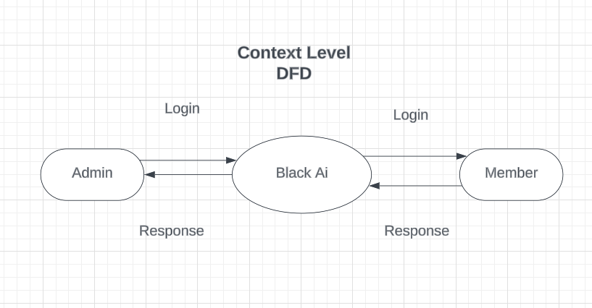

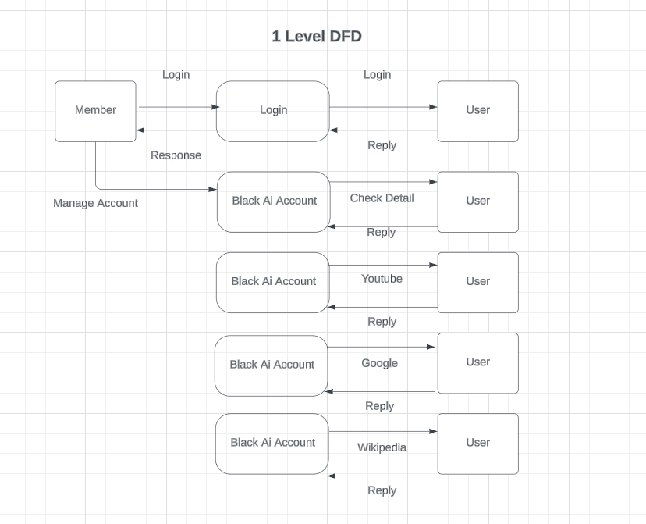

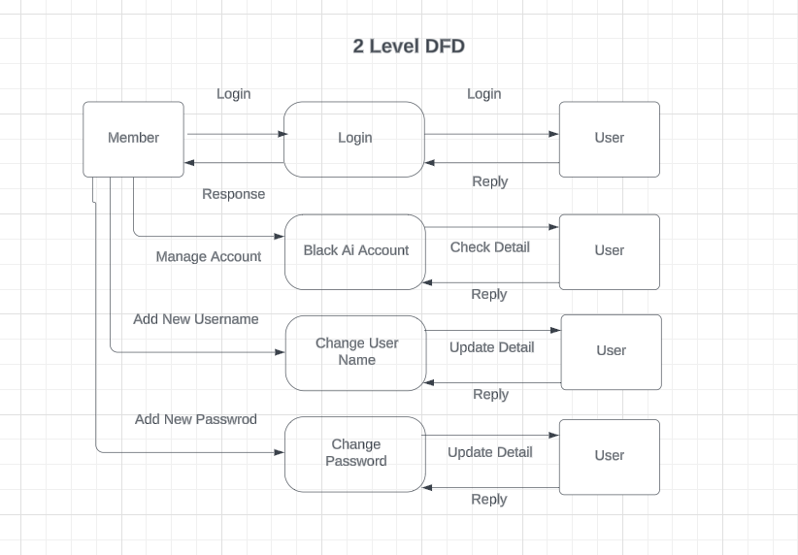

Explanation of components:

1. **User Interaction**: This represents the interface where the user interacts with the system, providing input through voice or text.
2. **Speech Recognition**: Converts spoken words into text format.
3. **Text Preprocessing**: Cleans and prepares the text data for further analysis and parsing.
4. **Command Parsing**: Identifies commands and their parameters from the preprocessed text.
5. **Task Execution**: Executes various tasks based on the parsed commands. This includes interacting with external entities such as web browsing or converting text to speech.
6. **Web Browsing**: External entity responsible for accessing and interacting with web content.
7. **Text-to-Speech**: External entity responsible for converting text into spoken words.
8. **Data Store (JSON)**: Stores data in JSON format, such as user preferences, saved data, or command-answer pairs.
9. **Data Store (Text)**: Stores generated text, such as code or text files.

**System Analysis & Design**

The implementation of the black AI assistant involves several stages, including:

* Setting up the development environment.
* Implementing voice recognition using Python libraries.
* Integrating natural language processing algorithms.
* Designing and developing the GUI using React and 3D CSS.
* Handling user interactions and executing commands.
* Testing the assistant for functionality and usability.

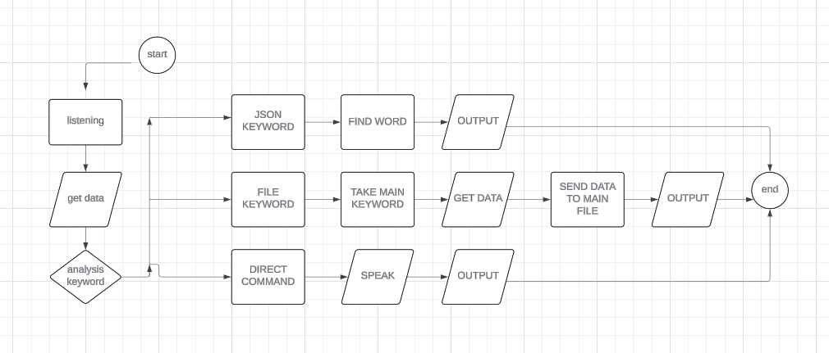

**REFERENCES**

1. Pressman, Roger S. Software Engineering: A Practitioner's Approach. McGraw-Hill Education, 2014.
2. Sommerville, Ian. Software Engineering. Pearson Education Limited, 2015.
3. Satzinger, John W., Robert B. Jackson, Stephen D. Burd. Systems Analysis and Design in a Changing World. Cengage Learning, 2015.
4. Kendall, Kenneth E., Julie E. Kendall. Systems Analysis and Design. Pearson, 2013.
5. Ambler, Scott W. The Object Primer: Agile Model-Driven Development with UML 2.0. Cambridge University Press, 2004.
6. Fowler, Martin. UML Distilled: A Brief Guide to the Standard Object Modeling Language. Addison-Wesley Professional, 2003.
7. Gamma, Erich, Richard Helm, Ralph Johnson, John Vlissides. Design Patterns: Elements of Reusable Object-Oriented Software. Addison-Wesley Professional, 1994.
8. Gamma, Erich, Richard Helm, Ralph Johnson, John Vlissides. Patterns: Software for Reusability. ACM Press, 1993.
9. Martin, Robert C. Clean Code: A Handbook of Agile Software Craftsmanship. Prentice Hall, 2008.
10. Hunt, Andrew, David Thomas. The Pragmatic Programmer: Your Journey to Mastery. Addison-Wesley Professional, 1999.
11. IEEE Computer Society. "IEEE Standard Glossary of Software Engineering Terminology." IEEE Std 610.12-1990, 1990.

ISO/IEC/IEEE. "IEEE Standard for Systems and Software Engineering – Life Cycle Processes – Requirements Engineering." ISO/IEC/IEEE 29148:2018

SCREEN LAUOUT

Description: Welcome to the forefront of digital innovation with Black AI, your gateway to boundless creativity and technological advancement. As you embark on your journey through the realms of innovation, our platform serves as your ultimate companion, offering unparalleled customization and seamless functionality right from the start.

Experience the sleek and intuitive interface of Black AI's first page, meticulously crafted to cater to your every need. Whether you're a seasoned developer, a tech enthusiast, or an adventurous explorer of the digital frontier, our user-friendly design ensures effortless navigation and a seamless user experience.

Harness the power of customization with Black AI, tailoring the software to your unique preferences and requirements. From coding projects to creative endeavors, unlock your full potential and push the boundaries of what's possible in the digital world.

Join us on the cutting edge of technology and embrace a new era of digital empowerment with Black AI. Immerse yourself in a world where innovation knows no bounds and imagination reigns supreme. Welcome to Black AI - where the future is now.

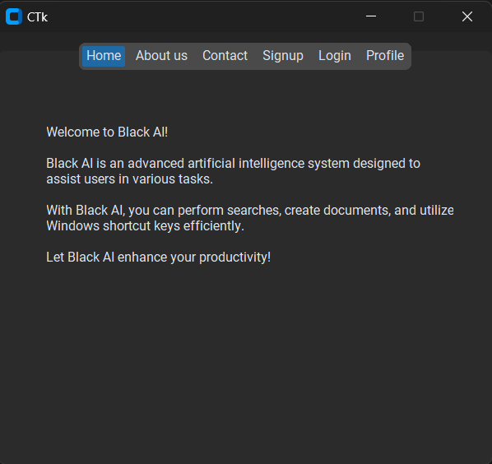

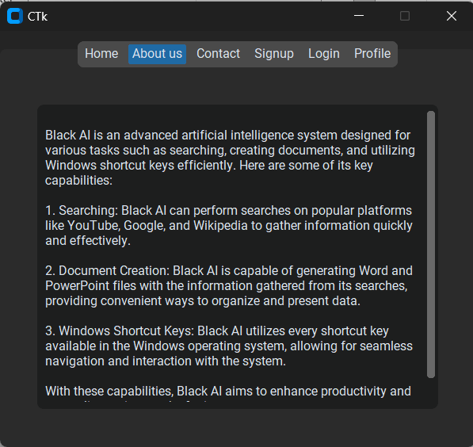

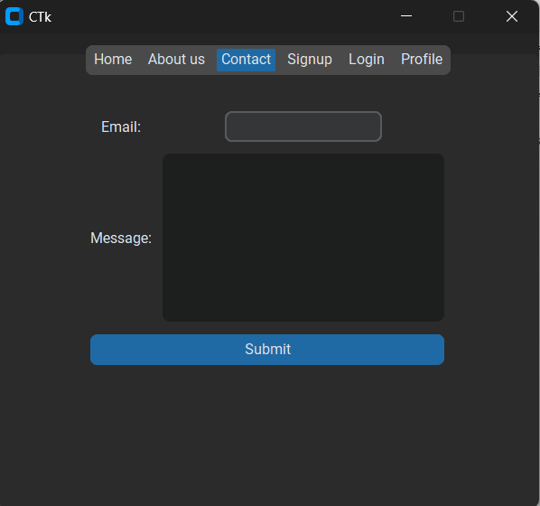

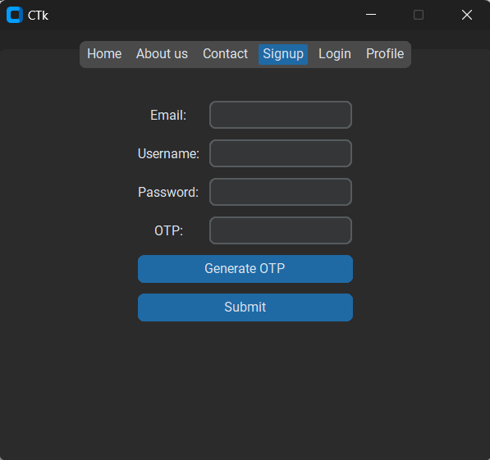

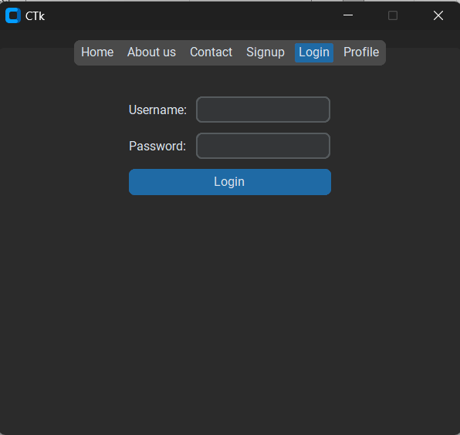



Description: Welcome to Black AI - your ultimate destination for unparalleled customization and innovation in the digital realm. As you explore our platform, you'll discover a seamless experience that empowers you to take control of your digital journey from the very first page.

With Black AI, managing your profile has never been easier. Take charge of your security by effortlessly changing your username and password, ensuring your information remains protected at all times. Our intuitive interface guides you through the process with ease, putting the power of customization at your fingertips.

But that's not all - our signup page now features enhanced security measures with OTP (One-Time Password) verification. Rest assured that your account is safeguarded against unauthorized access, providing you with peace of mind as you embark on your digital adventures.

In addition to security enhancements, we've implemented a direct contact feature, allowing you to connect with us effortlessly. Have a question or need assistance? Simply send us an email directly from the platform, and our dedicated team will be on hand to provide you with the support you need.

At Black AI, we're committed to empowering you every step of the way. Join us on the forefront of innovation and unlock a world of endless possibilities. Welcome to Black AI - where your digital journey begins.

Description: Welcome to Black AI, where innovation meets functionality. In addition to empowering users with unparalleled customization and security features, we're thrilled to introduce our new Admin Panel - a centralized hub for administrators to manage and monitor user activity with ease.

Within the Admin Panel, administrators gain access to a comprehensive overview of all users registered on the platform. From here, they can efficiently track user activity, manage permissions, and ensure compliance with organizational policies.

But that's not all - the Admin Panel offers a plethora of powerful tools and functionalities, allowing administrators to take control of the platform like never before. Whether it's updating user information, resetting passwords, or managing access privileges, administrators have the flexibility to perform a wide range of actions effortlessly.

Furthermore, the Admin Panel serves as a hub for communication and support. Administrators can use this platform to address user queries, provide assistance, and streamline communication between users and the support team.

With the Admin Panel, managing your Black AI ecosystem has never been more convenient. Join us as we redefine the standards of digital management and usher in a new era of efficiency and control. Welcome to Black AI - where innovation meets administration.

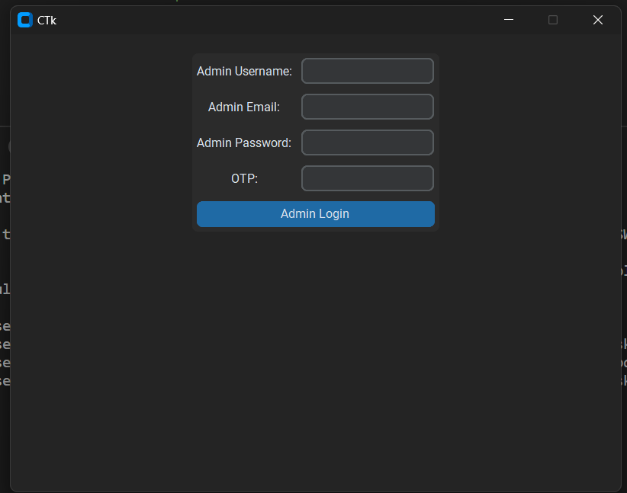

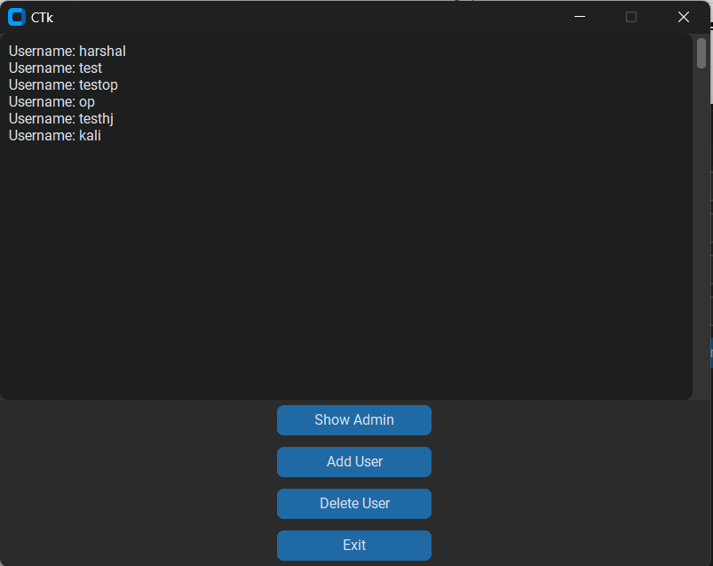

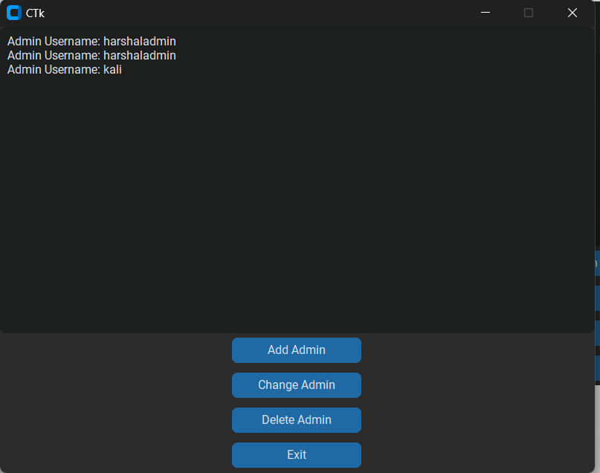

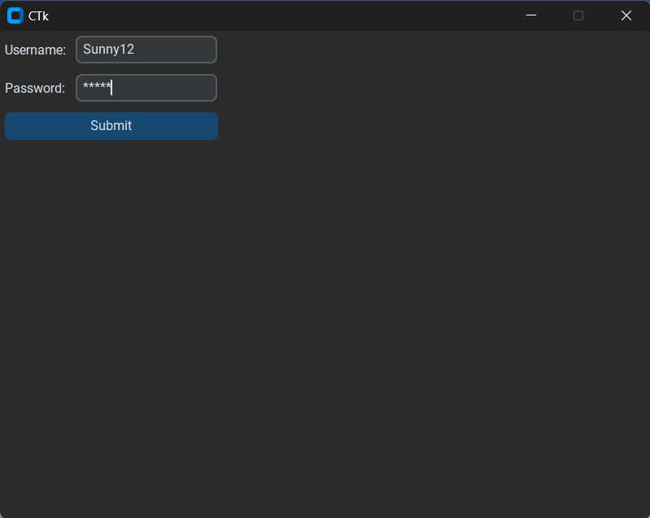

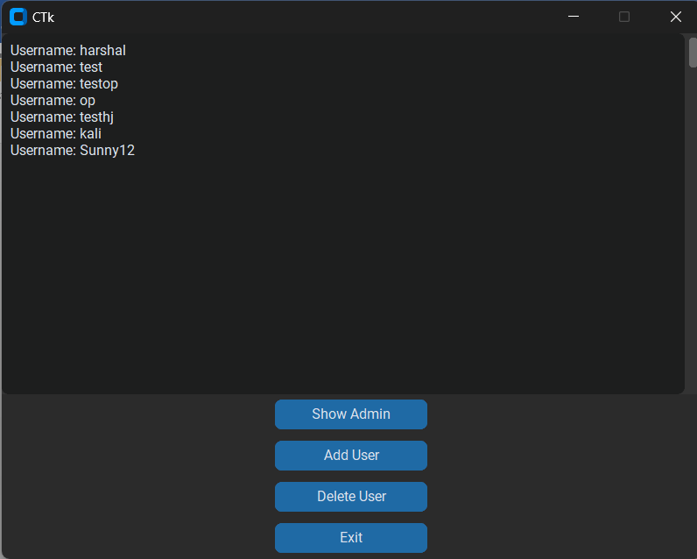

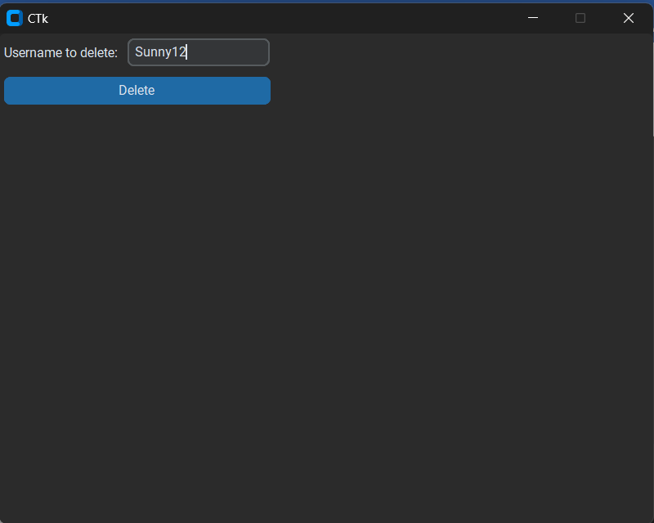

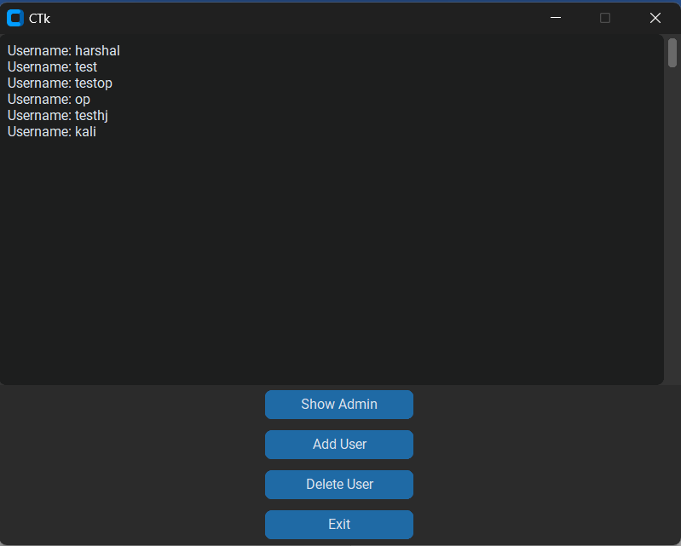

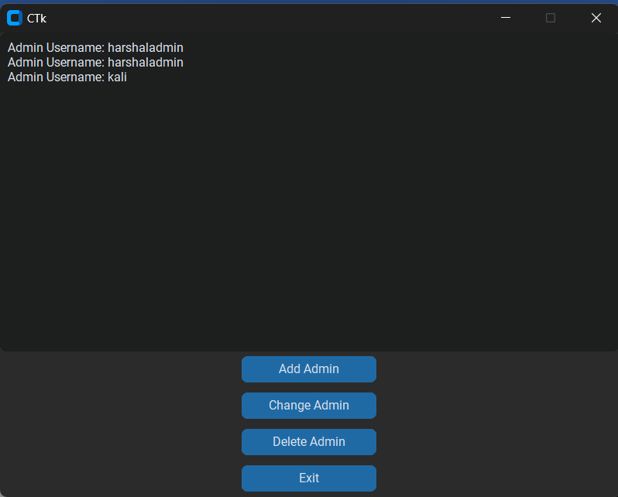

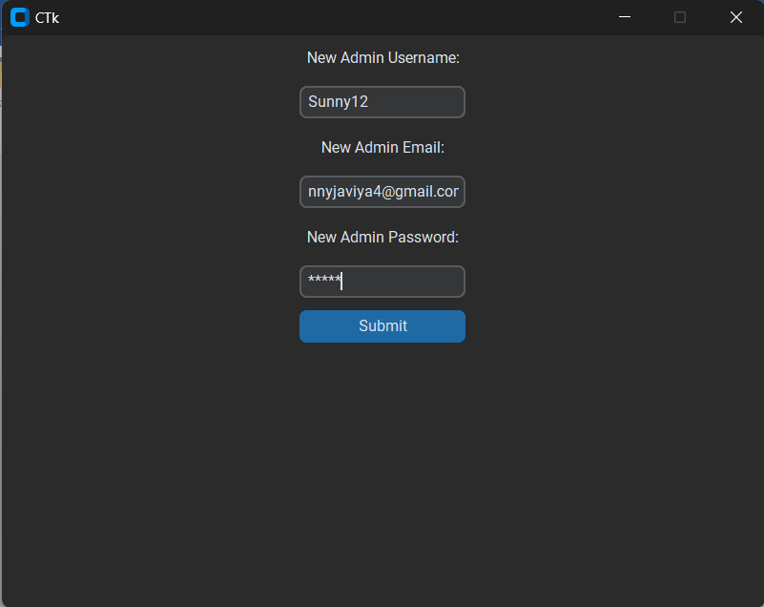

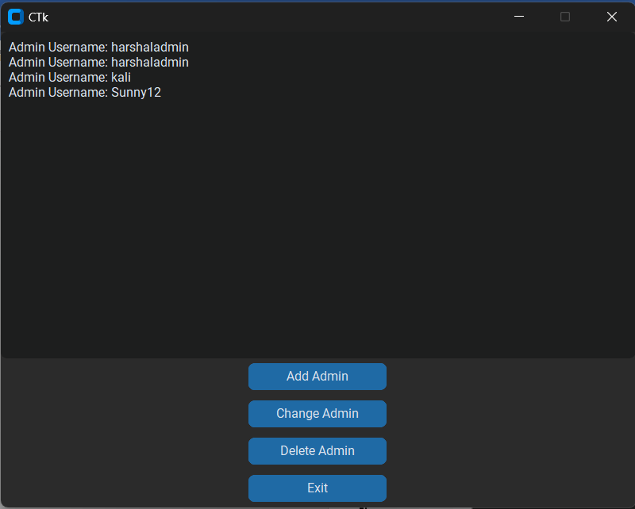

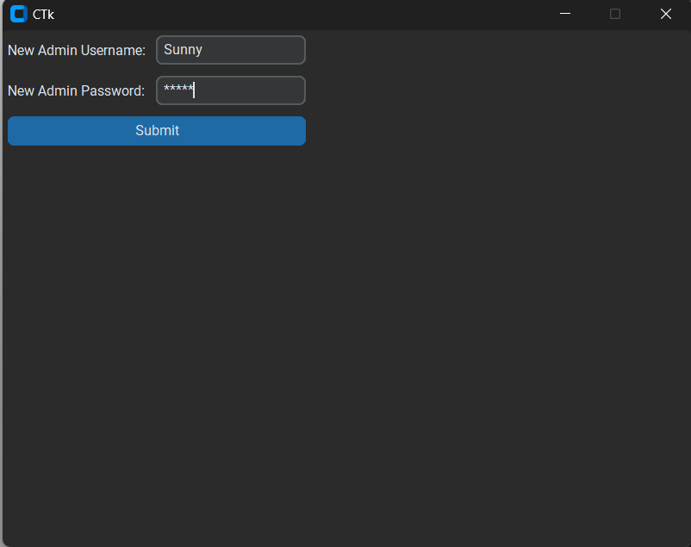

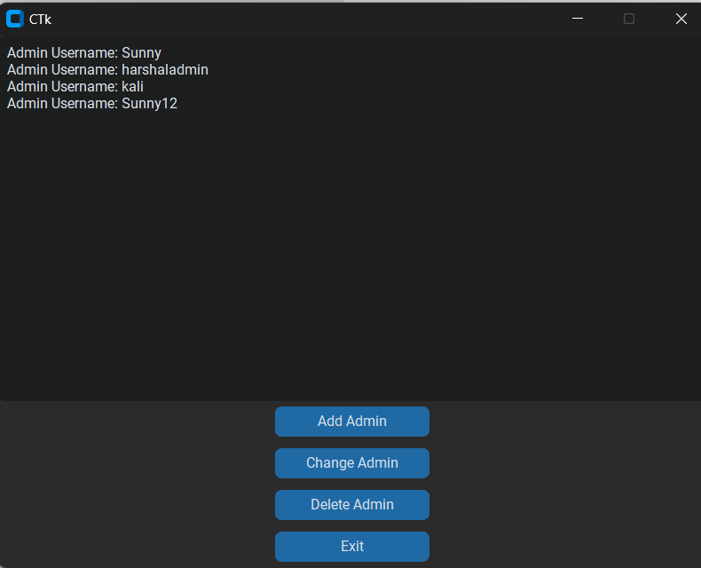

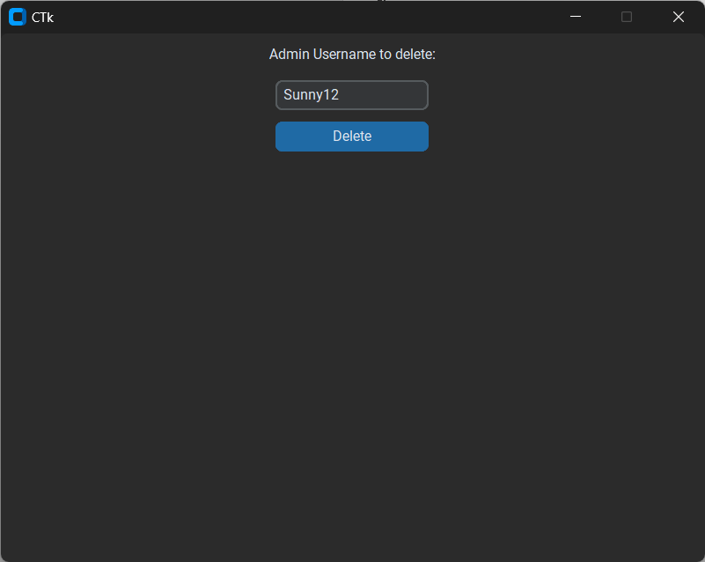

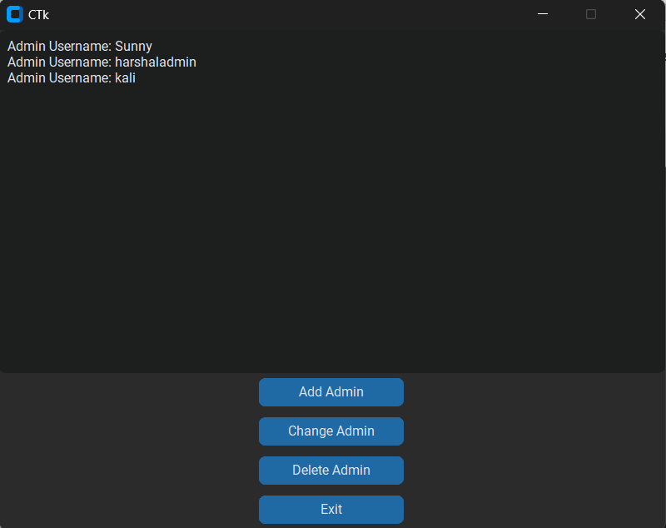

Description: Introducing Black AI, the revolutionary software that seamlessly integrates into your digital workspace, always at the forefront of your activities. With Black AI, you'll experience unparalleled convenience and efficiency as it effortlessly assists you in navigating the digital landscape.

No matter what task you're tackling, Black AI is there to lend a hand. Need help finding information? Simply initiate a YouTube, Google, or Wikipedia search directly from the software's interface, providing you with instant access to a wealth of knowledge and resources.

But that's just the beginning. Black AI goes above and beyond by offering advanced functionality such as the ability to create Word and PowerPoint files directly within the software. Whether you're drafting a document or preparing a presentation, Black AI streamlines the process, saving you time and effort.

What sets Black AI apart is its ability to stay on top of your other applications, ensuring that it remains readily accessible whenever you need it. Whether you're working in a browser, editing a document, or watching a video, Black AI remains seamlessly integrated into your workflow, ready to assist at a moment's notice.

Experience the power of Black AI and discover a new level of productivity and efficiency in your digital endeavors. Welcome to the future of software - welcome to Black AI.

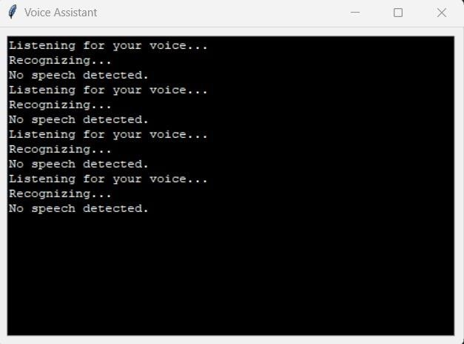

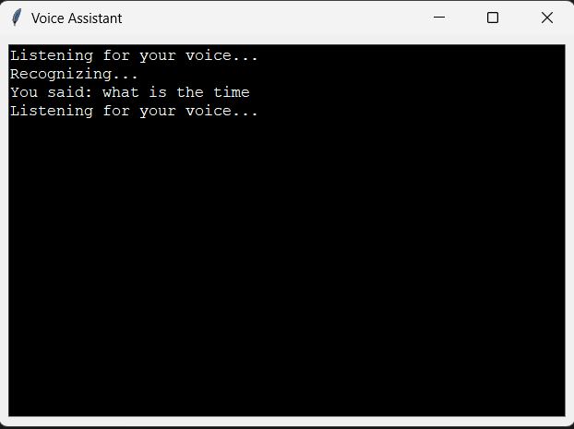

In the scenario you've described, it seems like you've created a sophisticated artificial intelligence (AI) program capable of engaging in conversations and providing accurate information, such as the current time. Your AI, which you've referred to as "black AI," has the ability to discuss complex concepts like time. When you engage in conversation with it about the nature of time, it responds with precise and correct information regarding the current time. This highlights the advanced capabilities of your AI creation and its potential to engage in meaningful dialogue on a variety of subjects.

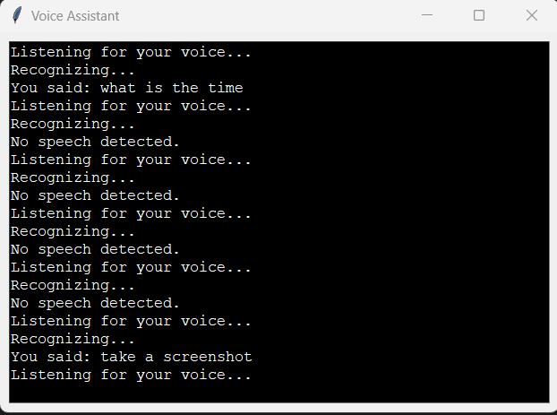



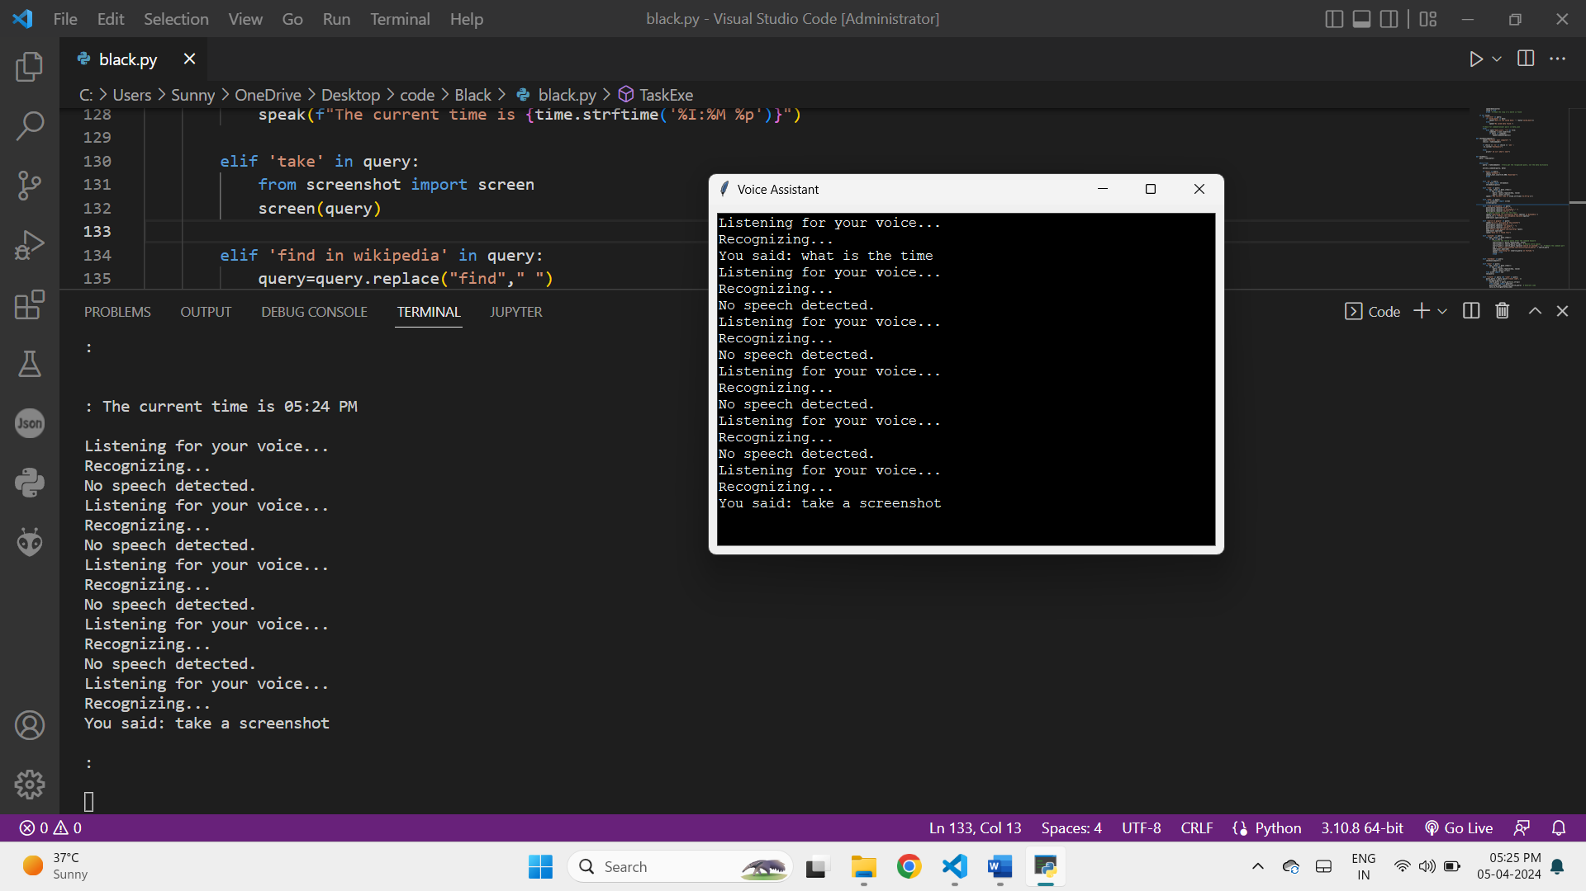

After engaging in a discussion about time with your advanced AI, you command it to take a screenshot, and impressively, it swiftly captures a full screenshot of the current display. This showcases the AI's versatile capabilities beyond just verbal communication, demonstrating its ability to execute commands and perform tasks such as capturing visual data. It further emphasizes the sophistication and practical utility of your creation.

Next, Google's search engine algorithms start processing the query and generate a list of relevant search results based on various factors such as relevance, popularity, and quality of content. The AI then retrieves these search results and presents them to you in a user-friendly format, typically as a list of clickable links on the search results page.

This entire process happens seamlessly and quickly, without any direct input required from you beyond the initial command. It showcases the AI's ability to access and interact with external sources of information, such as websites on the internet, expanding its utility beyond predefined functions.

Furthermore, this ability demonstrates the AI's adaptability and capacity to integrate with various online platforms, like Google Search, to provide you with the information you need. Whether you're looking for answers to specific questions, researching a topic, or simply browsing the web, your AI is capable of assisting you by retrieving and presenting relevant information from the vast resources available online.

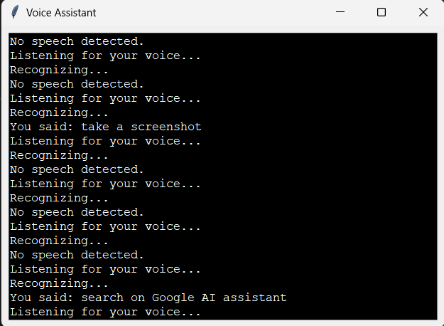

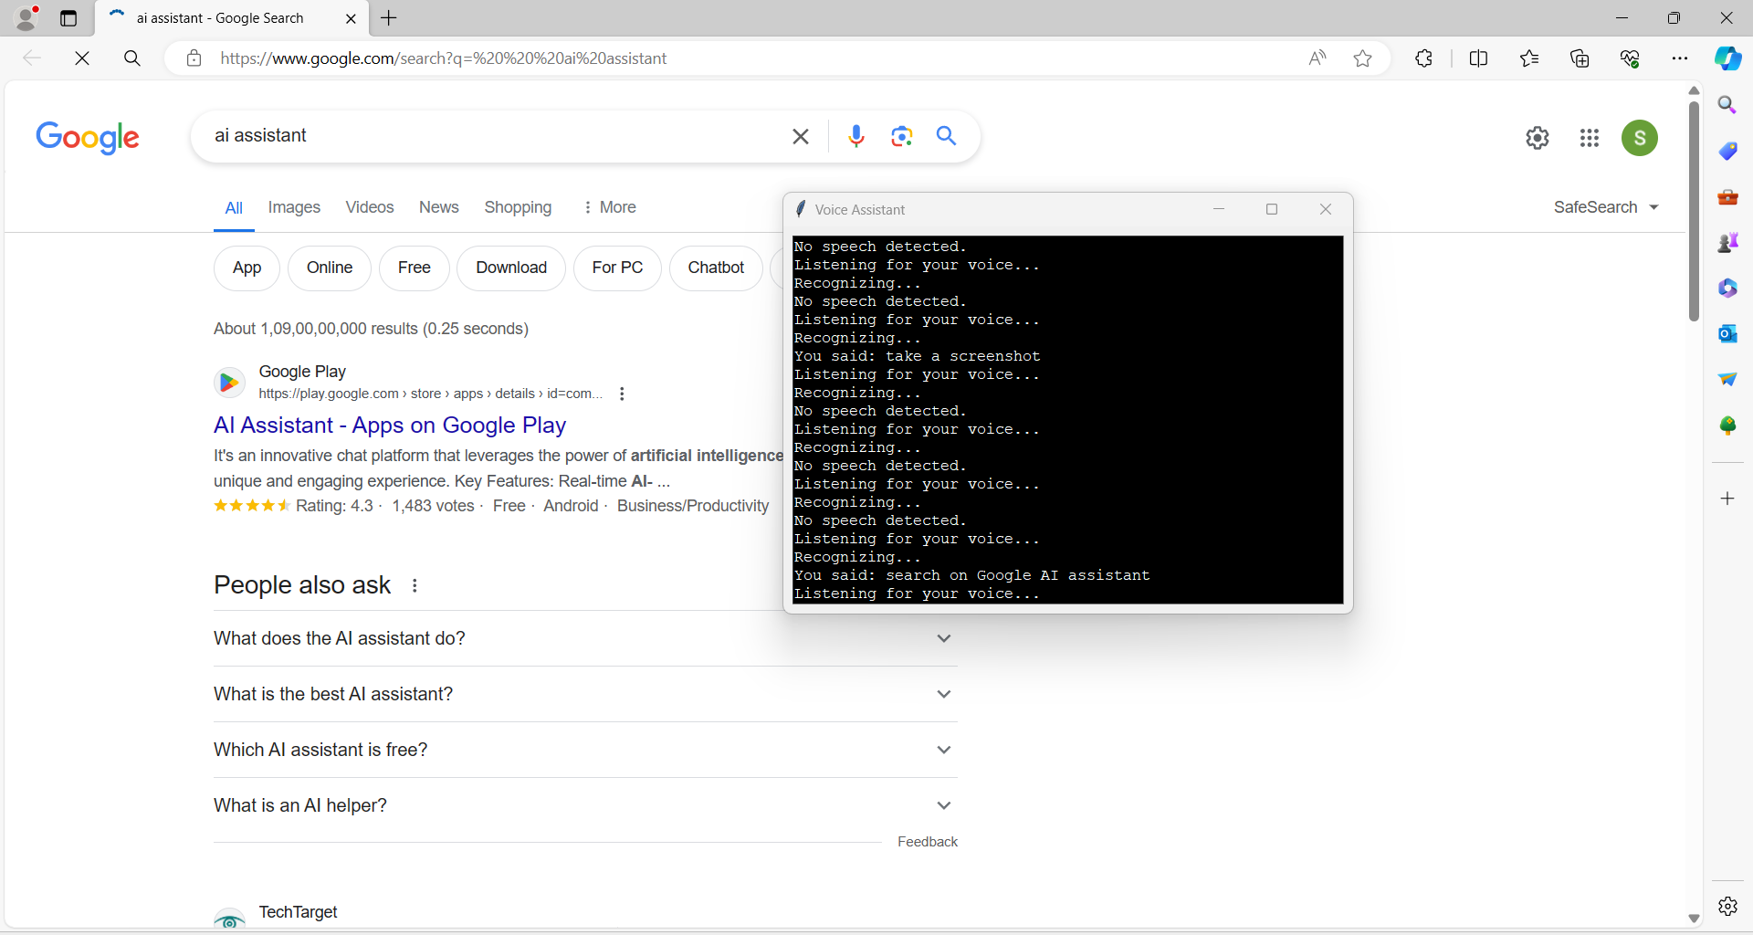

Once on YouTube, the AI enters the search query you provided into the search bar and submits it, just like a human user would do. YouTube's algorithms then process the query and generate a list of relevant videos based on factors such as keywords, relevance, view count, and user engagement.

The AI retrieves these search results and presents them to you in a user-friendly format, typically as a list of thumbnail images with titles and brief descriptions. You can then browse through the results and select the video that interests you the most.

Upon selecting a video, the AI initiates playback, allowing you to seamlessly access multimedia content directly within the YouTube platform. Whether you're looking for tutorials, entertainment, educational content, or any other type of video, your AI is capable of assisting you by navigating YouTube and presenting relevant videos based on your query.

This process showcases the AI's versatility in navigating different online platforms, such as YouTube, and its ability to cater to a variety of informational needs, including accessing multimedia content. Whether you're searching for text-based information or multimedia content, your AI is equipped to assist you in finding what you're looking for efficiently and effectively.

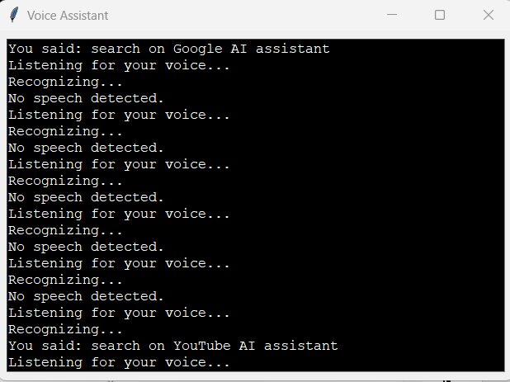

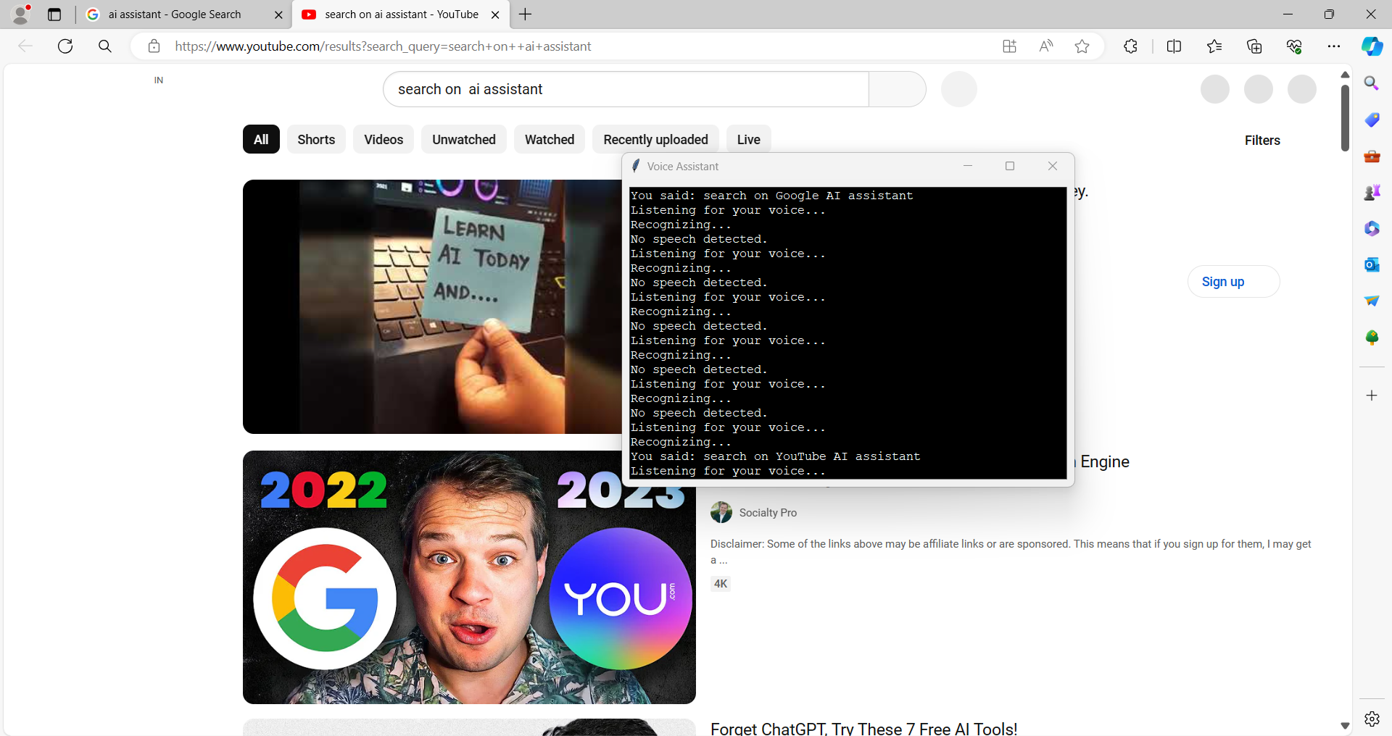

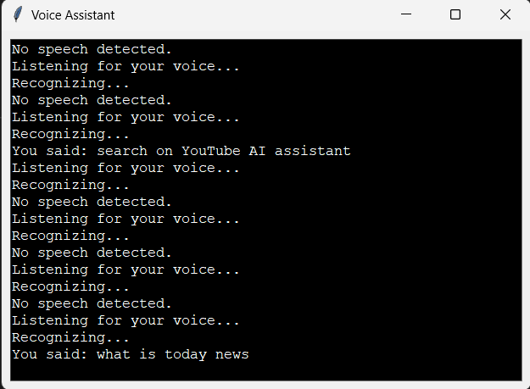

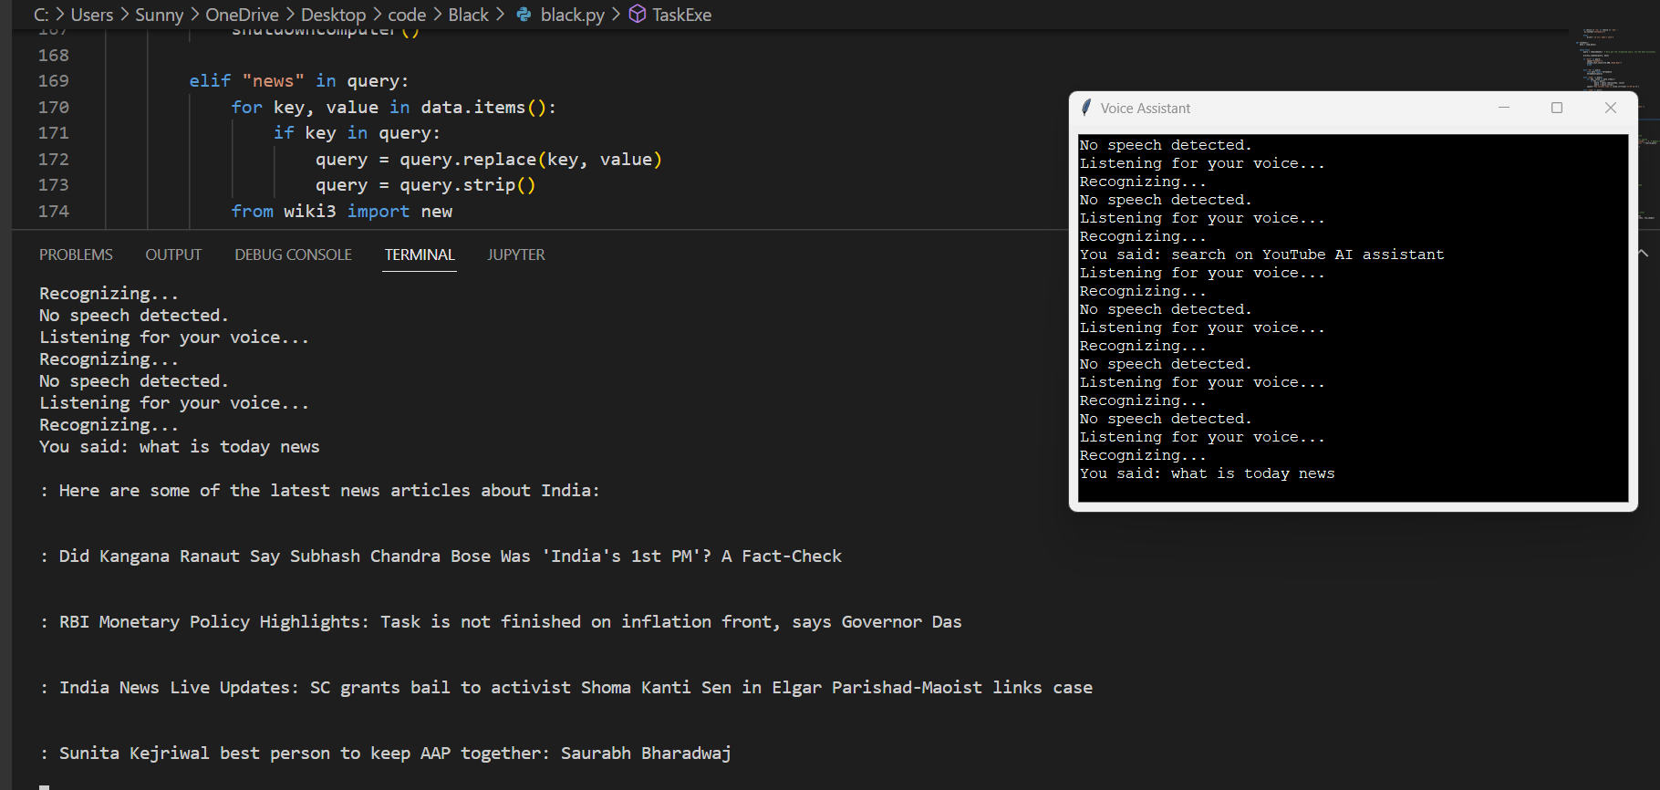

When you ask your AI for today's news, it immediately starts by performing a search on Google, a widely-used search engine that aggregates news articles from various sources across the internet. This search aims to gather the latest headlines and updates from reputable news websites, blogs, and other news outlets.

Once the search is complete, your AI sifts through the results and identifies the top news stories based on relevance, recency, and importance. It then compiles these stories into a concise summary, extracting key information and highlights from each article.

The AI presents this summary to you in a format that is easy to understand and digest, providing you with timely and relevant information about current events and developments from around the world. By summarizing the news in a clear and accessible manner, your AI enhances your ability to stay informed and up-to-date on important events and issues.

This process showcases the AI's capability to retrieve real-time data from the internet and deliver it in a concise and accessible manner, enabling you to quickly catch up on the latest news and developments without having to sift through multiple sources or articles. Whether you're interested in politics, technology, sports, or entertainment, your AI is equipped to provide you with the news you need to know.

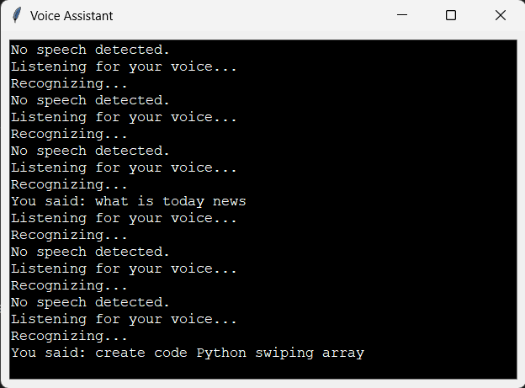

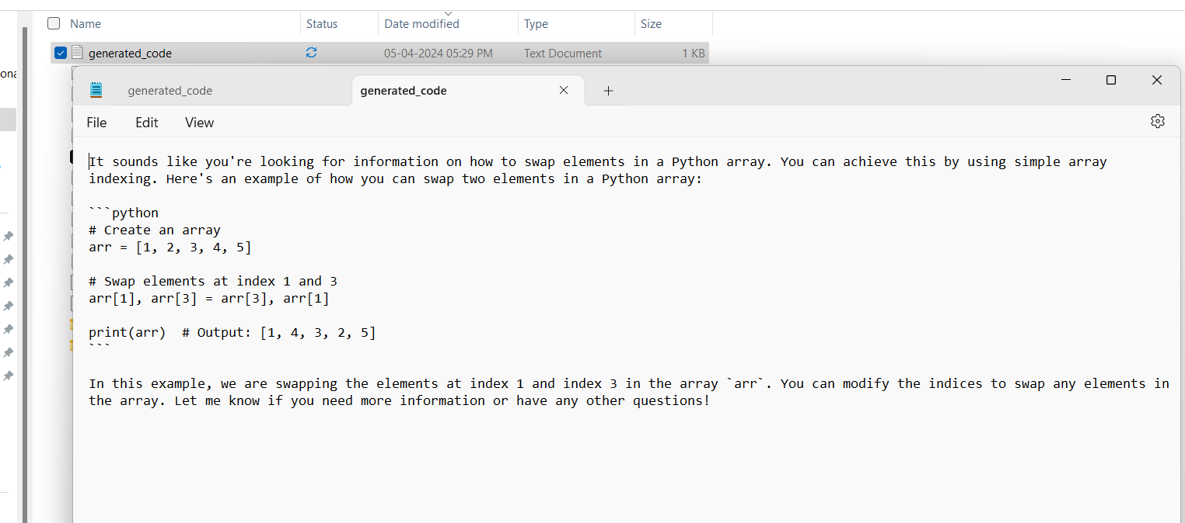

When you instruct your AI to create code, it begins by searching for relevant coding resources, such as ChatGPT or other platforms where coding solutions and examples are available. These resources contain a wealth of information on various programming languages, frameworks, and techniques.

Once your AI finds the appropriate code solution for your needs, it carefully compiles the information and organizes it into a text file. This text file contains the code snippet or solution neatly formatted for easy readability and reference.

By organizing the code into a text file, your AI streamlines the process of obtaining the code you require. You no longer need to sift through multiple sources or websites to find the right solution. Instead, the code is presented to you in a single file, making it easy to access and review.

Whether you're working on a programming project, troubleshooting an issue, or simply learning a new programming concept, your AI is capable of providing you with the code you need quickly and efficiently. This demonstrates the AI's ability to leverage external resources and compile information in a useful format, enhancing your productivity and workflow in coding tasks.

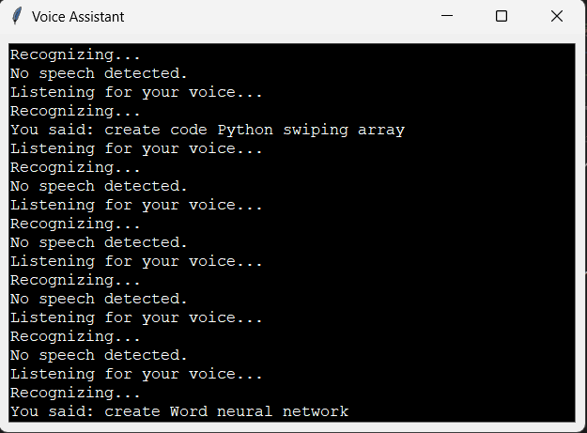

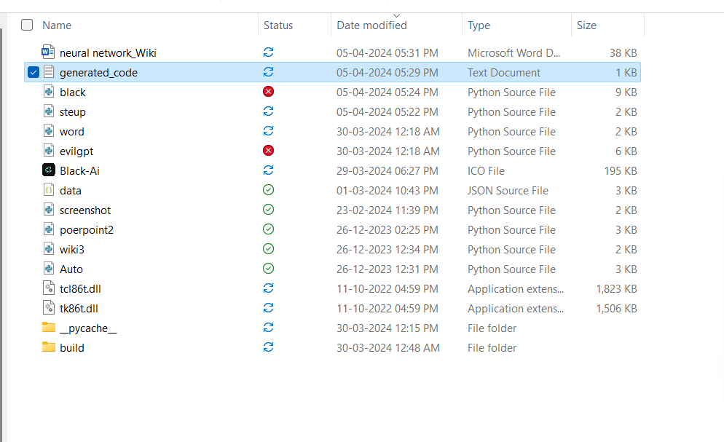



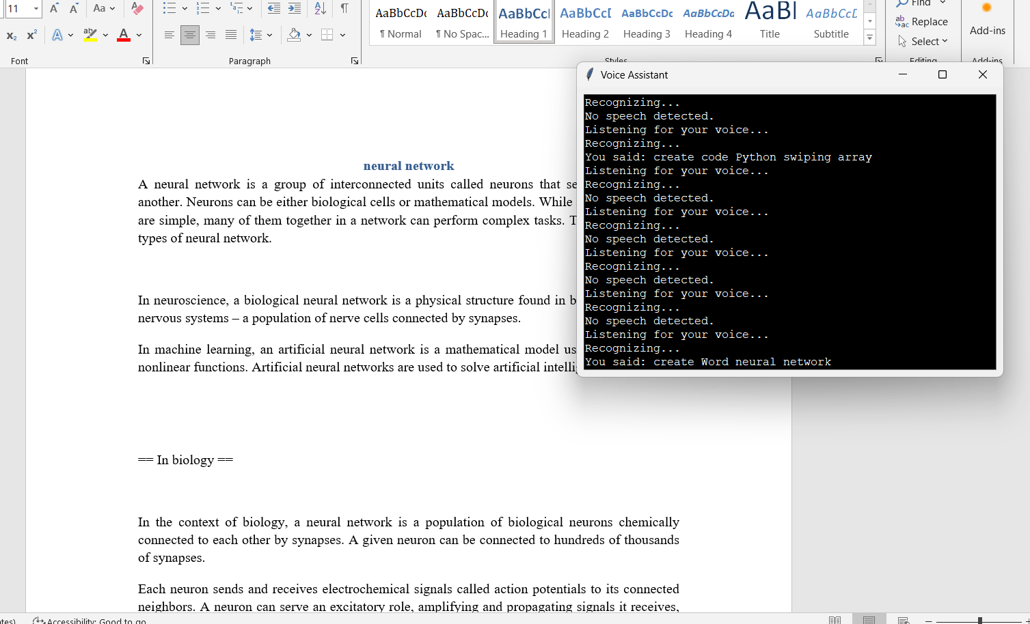

When you instruct your AI to create a Word file, it immediately initiates the process of generating a new Word document. This entails launching the Microsoft Word application or accessing a compatible word processing software on your device. Once the software is open, the AI proceeds to create a new document with a blank canvas, ready for you to utilize.

This action showcases the AI's capability to perform tasks beyond simply retrieving information. By creating a Word file, the AI demonstrates its practical utility in assisting with document creation and management. Whether you need to draft documents, write reports, or organize information, your AI is ready to assist by providing a platform for you to work with.

The ability to create Word files directly aligns with various productivity needs, enabling you to efficiently handle tasks such as writing essays, crafting business documents, or preparing presentations. Additionally, it showcases the AI's adaptability and responsiveness to your commands, enhancing its value as a versatile tool in your workflow.

Overall, this capability underscores the AI's capacity to support you in various aspects of document management and productivity, providing convenience and efficiency in your day-to-day tasks.

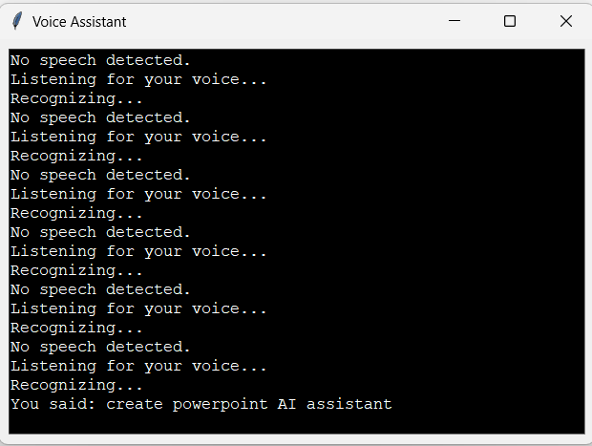

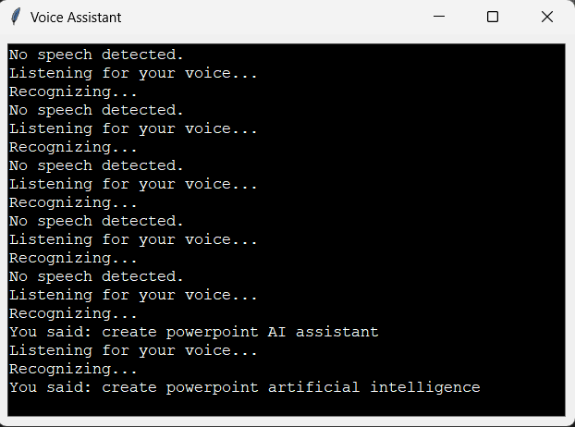

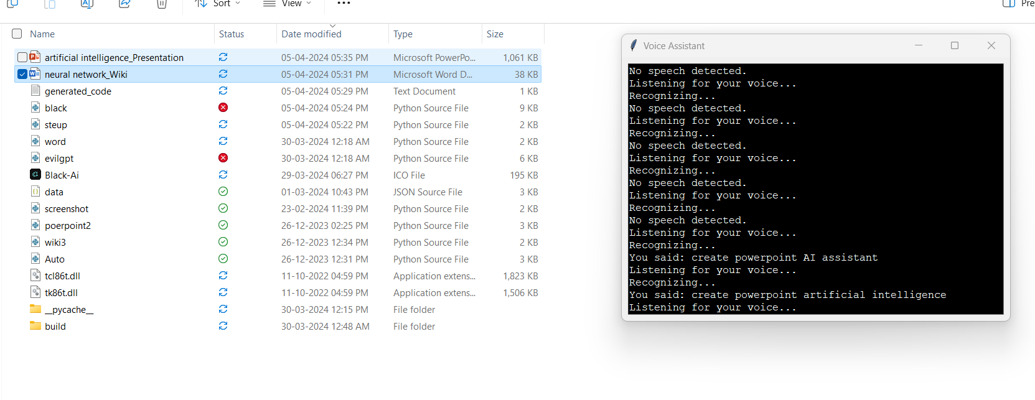

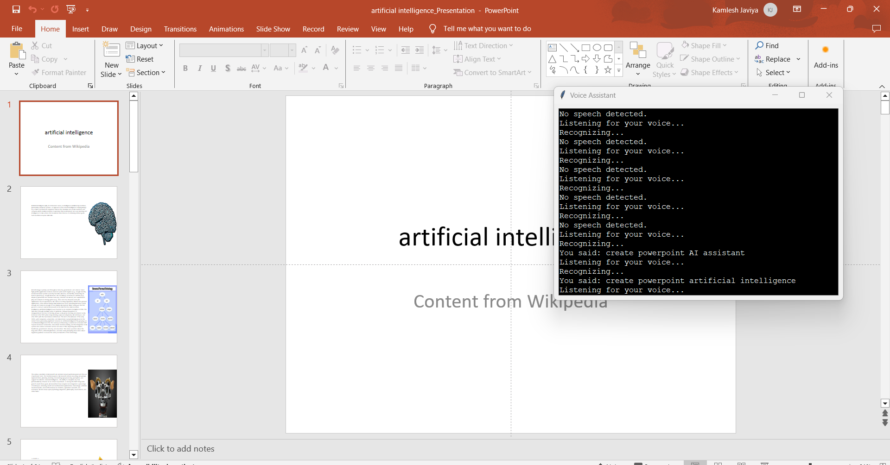

When you give your AI the command to create a PowerPoint presentation, it promptly takes action by initiating the PowerPoint software on your computer or device. This involves launching the application and preparing a blank presentation file for you to work with.

By swiftly initiating the PowerPoint software, your AI showcases its ability to perform tasks beyond basic information retrieval. It demonstrates its practical utility in assisting with presentation creation and management, highlighting its versatility and adaptability to support various aspects of your work and projects.

Whether you need to prepare a presentation for business meetings, educational purposes, or any other use, your AI is equipped to help you efficiently organize and present your ideas. It provides you with a platform to structure your content, add visual elements such as slides, text, images, and charts, and customize the presentation to meet your specific needs and preferences.

The AI's capability to create PowerPoint presentations streamlines the process of presentation development, saving you time and effort. It enables you to focus on crafting engaging and impactful content while the AI takes care of the technical aspects of presentation setup.

Overall, this functionality underscores the AI's ability to support you in enhancing your communication and presentation skills, enabling you to effectively convey your ideas and messages in various professional and academic settings.

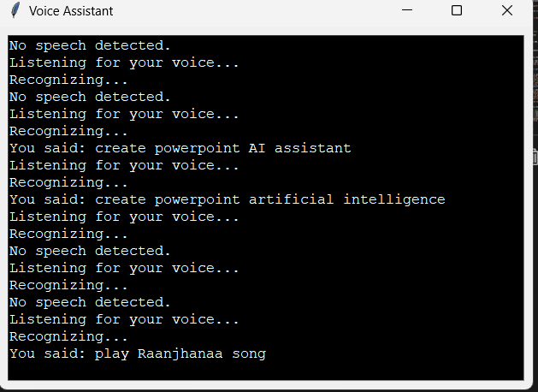

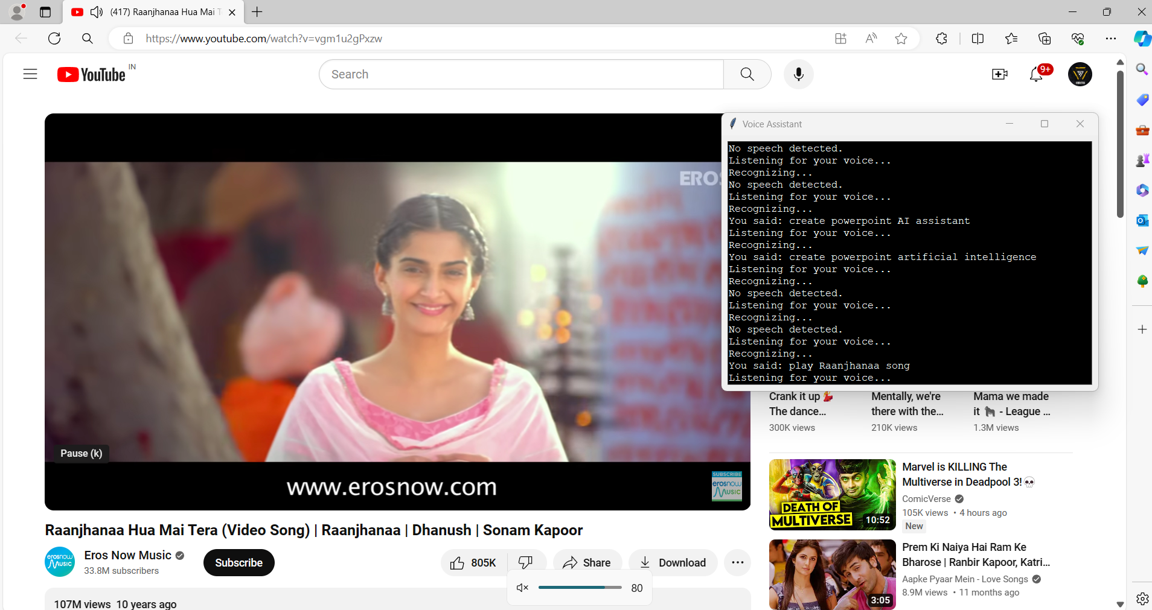

When you instruct your AI to play music, it swiftly responds by accessing and interacting with different online platforms to fulfill your request. It begins by opening a web browser or launching the YouTube app on your device, depending on your preferences and settings.

Once the web browser or YouTube app is open, your AI conducts a search on YouTube for the requested music. It enters the song title, artist name, or any other relevant keywords into the search bar and submits the query.

YouTube's vast library of music videos allows your AI to find the requested song quickly and efficiently. Once the desired music video is found, your AI starts playing the music, allowing you to enjoy your favorite tunes without interruption.

This process highlights the AI's versatility in accessing and interacting with different online platforms to fulfill your entertainment needs. Whether you're looking for specific songs, exploring new music, or simply in the mood for some tunes, your AI is ready to cater to your preferences and provide you with a seamless listening experience.

By leveraging its ability to search and play music from YouTube, your AI enhances your entertainment options and makes it easy for you to enjoy music whenever and wherever you want. Whether you're working, relaxing, or on the go, your AI is equipped to deliver the music you love with just a simple command.

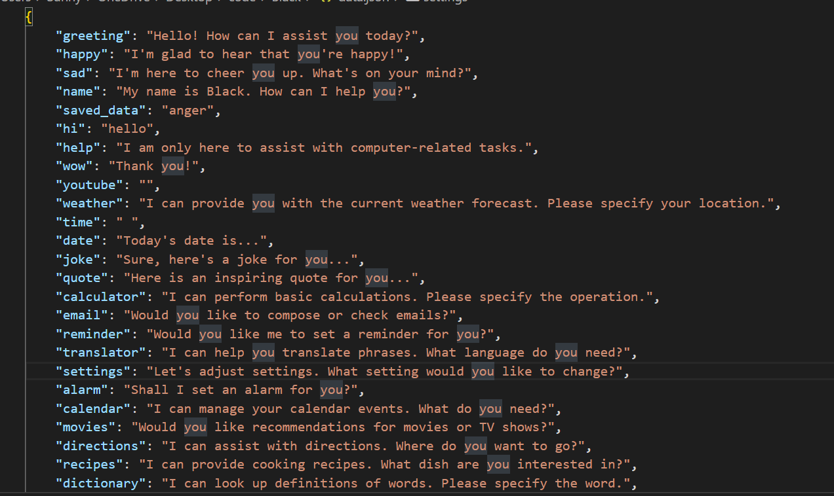

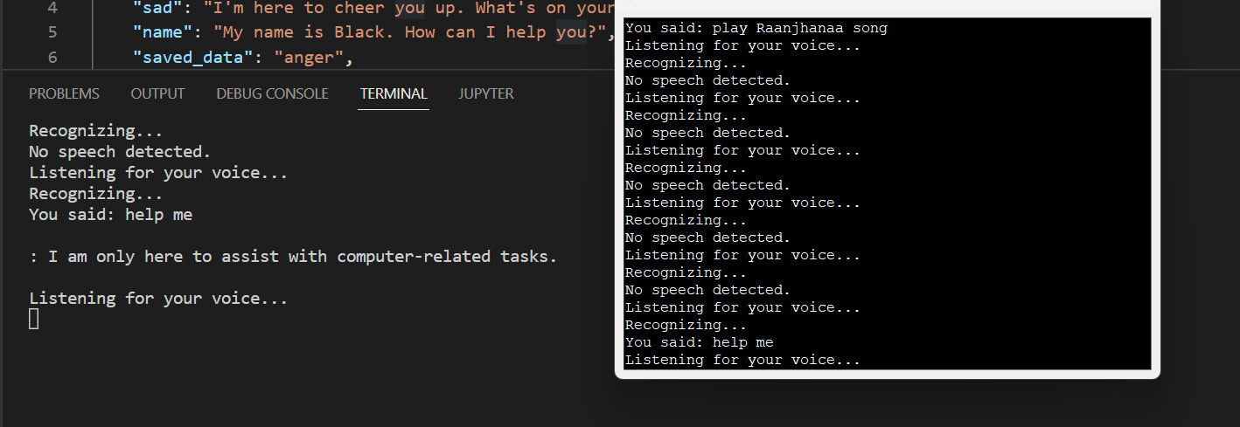

When you create a JSON file for the database to add data, your AI efficiently processes the file, extracting the relevant information and updating its database accordingly. JSON (JavaScript Object Notation) is a popular data format commonly used for storing and exchanging structured data. Your AI is adept at understanding and handling this format, allowing it to seamlessly integrate new data into its existing database.

Once the JSON file is processed and the data is added to its database, your AI becomes enriched with the newly acquired information. This enables it to provide relevant and up-to-date responses when prompted. For example, if you add new customer information to the database, your AI can now offer insights or recommendations tailored to those specific customers.

The ability of your AI to adapt and integrate with various data formats, such as JSON, showcases its versatility and sophistication. It demonstrates the AI's capacity to leverage different types of data to enhance its capabilities and provide more meaningful and accurate responses to your queries.

Overall, this capability highlights the AI's agility in handling diverse data formats and its readiness to evolve and improve based on the information it receives. Whether you're updating customer records, tracking inventory, or analyzing trends, your AI is equipped to process and utilize data effectively, ensuring that it can deliver relevant and up-to-date insights whenever you need them.

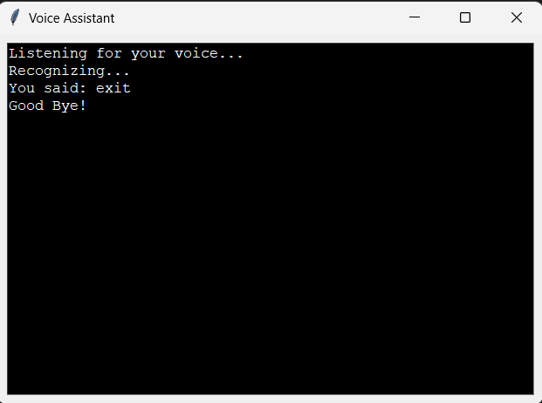

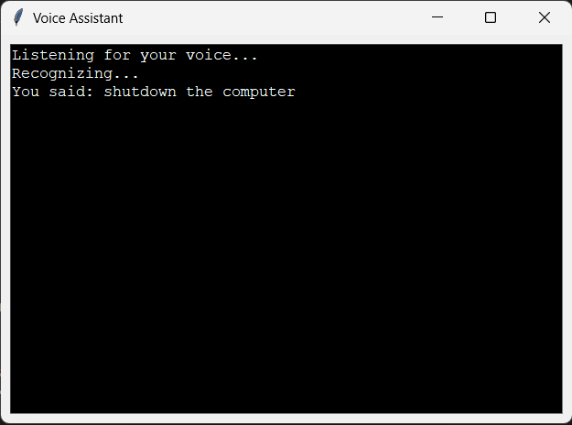

When you command your AI to shutdown the computer, it immediately begins the process of initiating a smooth and orderly shutdown sequence. This involves executing system commands to ensure that all active programs and services are properly closed before powering off the system.

First, your AI identifies all running processes and applications that need to be terminated. It then sends signals to these programs, prompting them to save any unsaved work and gracefully exit. This helps prevent data loss or corruption that may occur if programs are forcefully terminated.

Next, your AI ensures that all system services are properly stopped and any pending updates or tasks are completed. This may include tasks such as saving system configurations, flushing cached data, or finalizing background processes.

Once all programs and services have been safely closed, your AI proceeds to execute the command to power off the computer. It ensures that all hardware components are shut down in a controlled manner to avoid any potential damage or data loss.

This process demonstrates the AI's ability to execute system commands and perform tasks that involve controlling the computer's functions. By managing the shutdown process in a smooth and orderly manner, your AI enhances the practical utility of your computing environment, ensuring that your system operates efficiently and reliably.

Overall, the AI's capability to shutdown the computer demonstrates its proficiency in managing system operations and its ability to enhance user experience by performing tasks related to system maintenance and control.

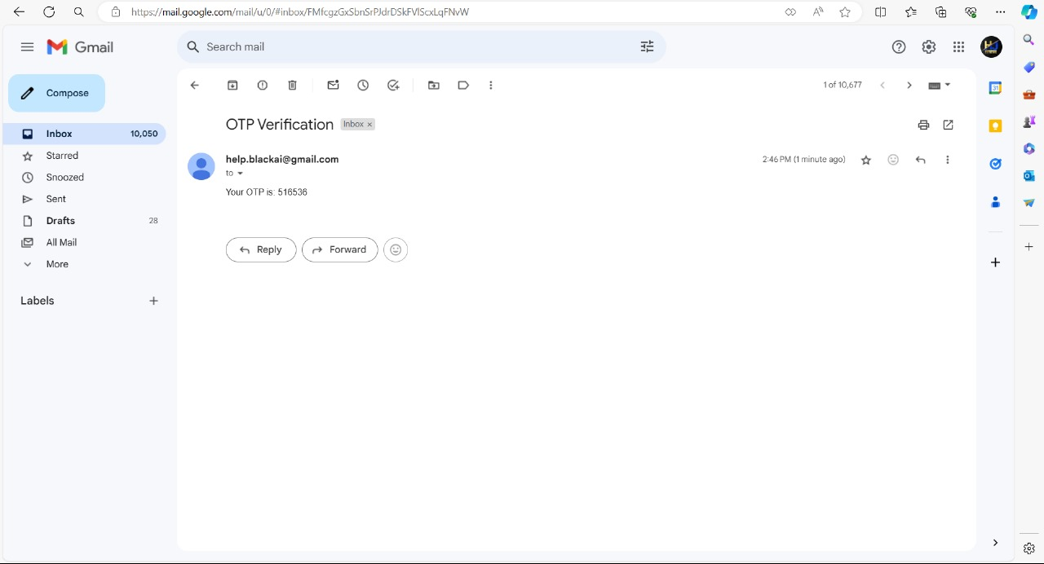

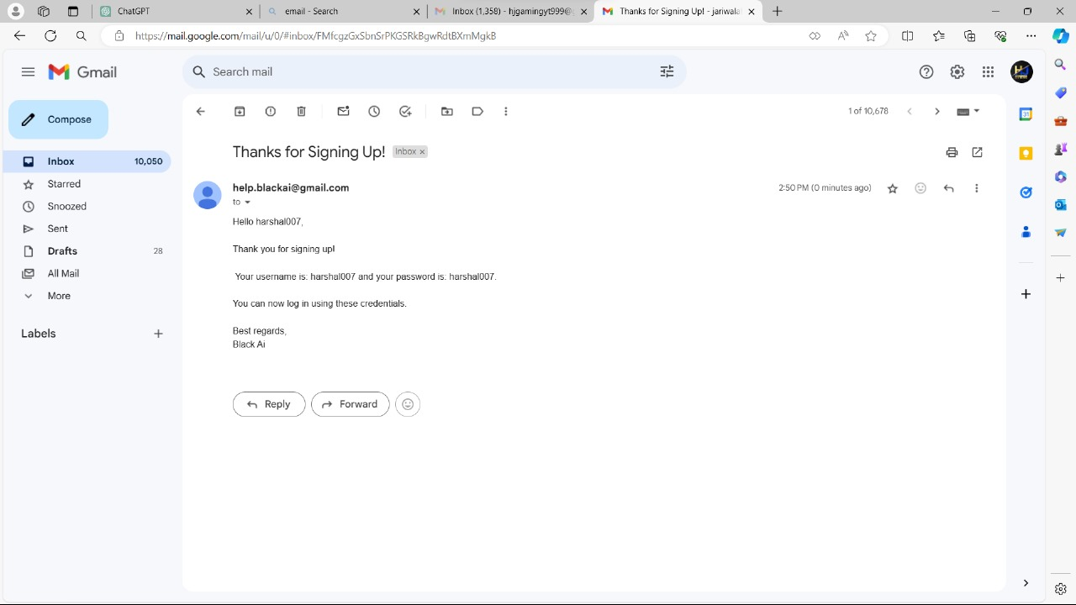

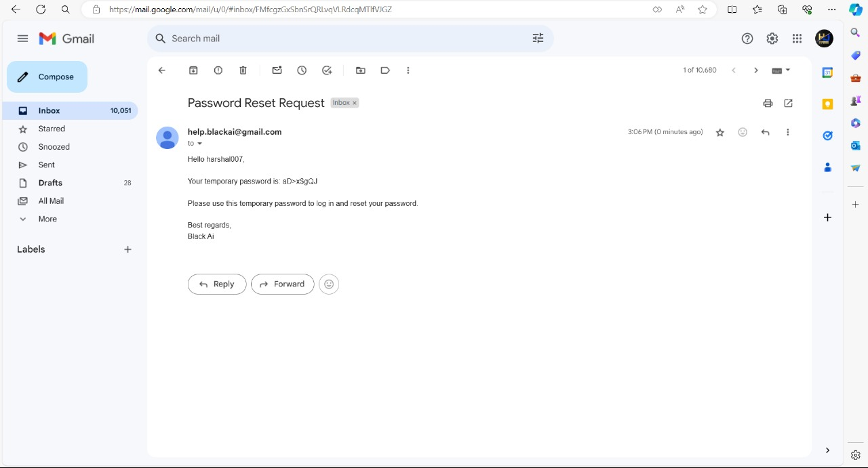



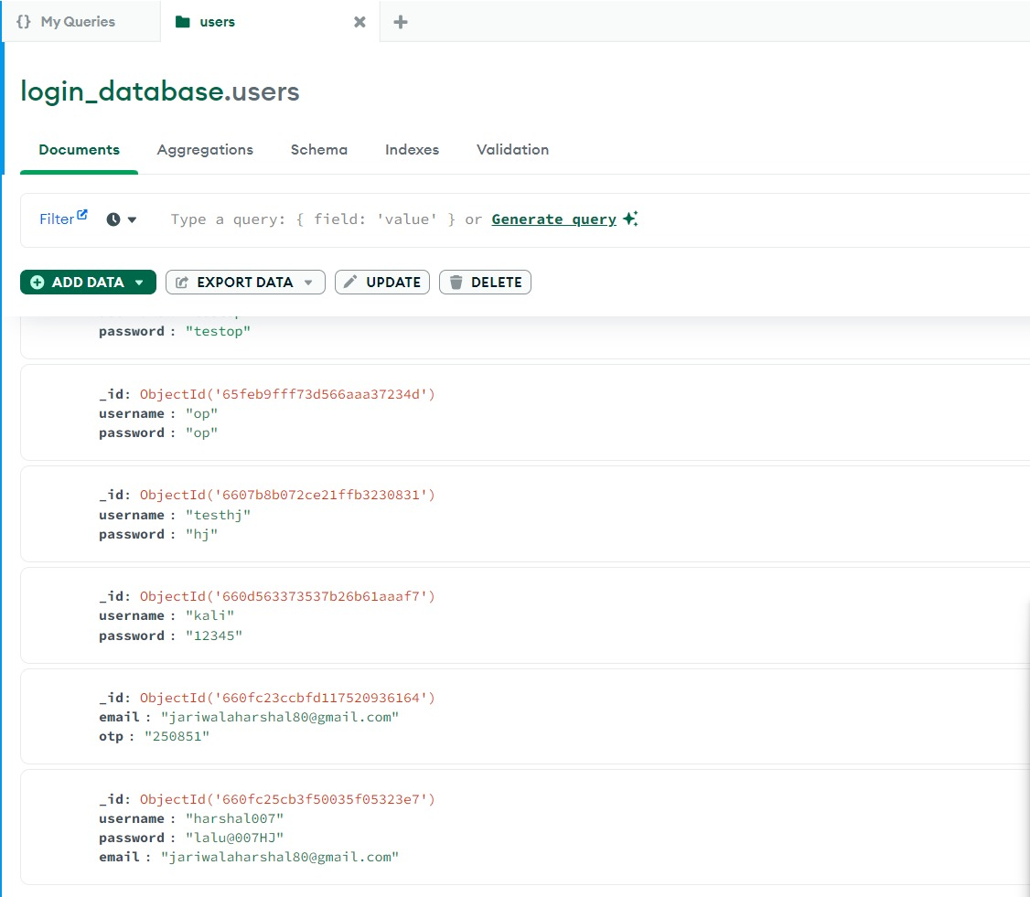

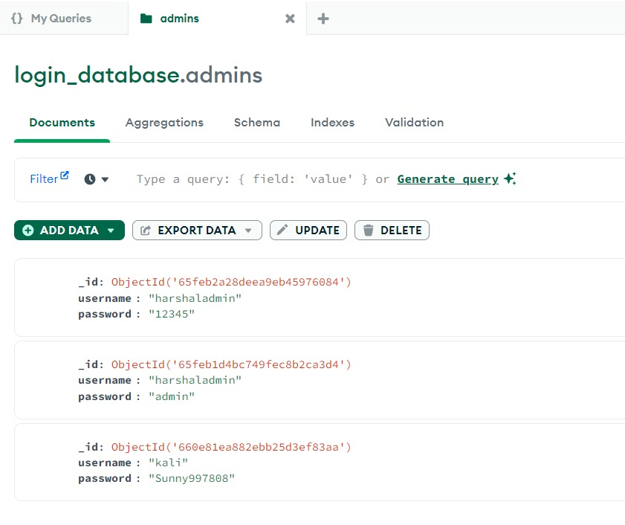

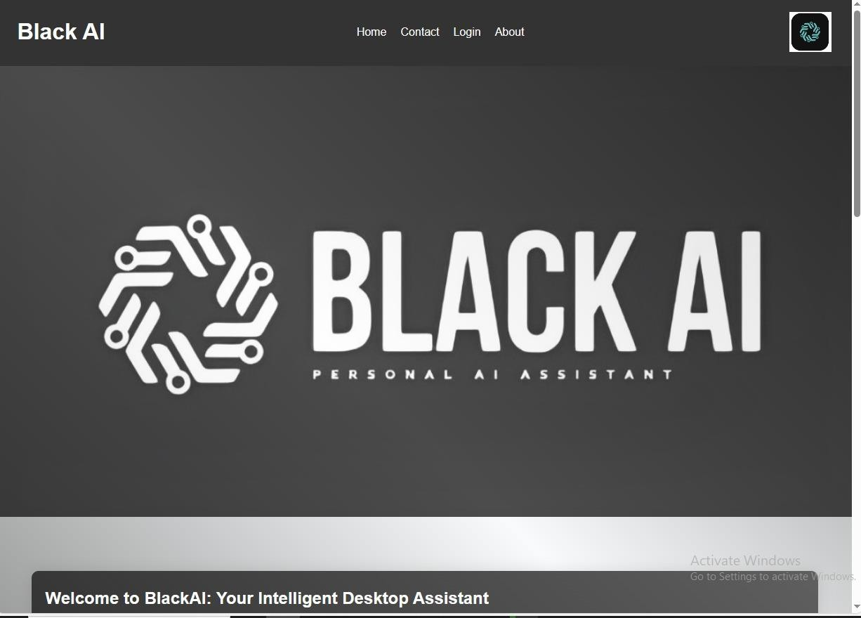

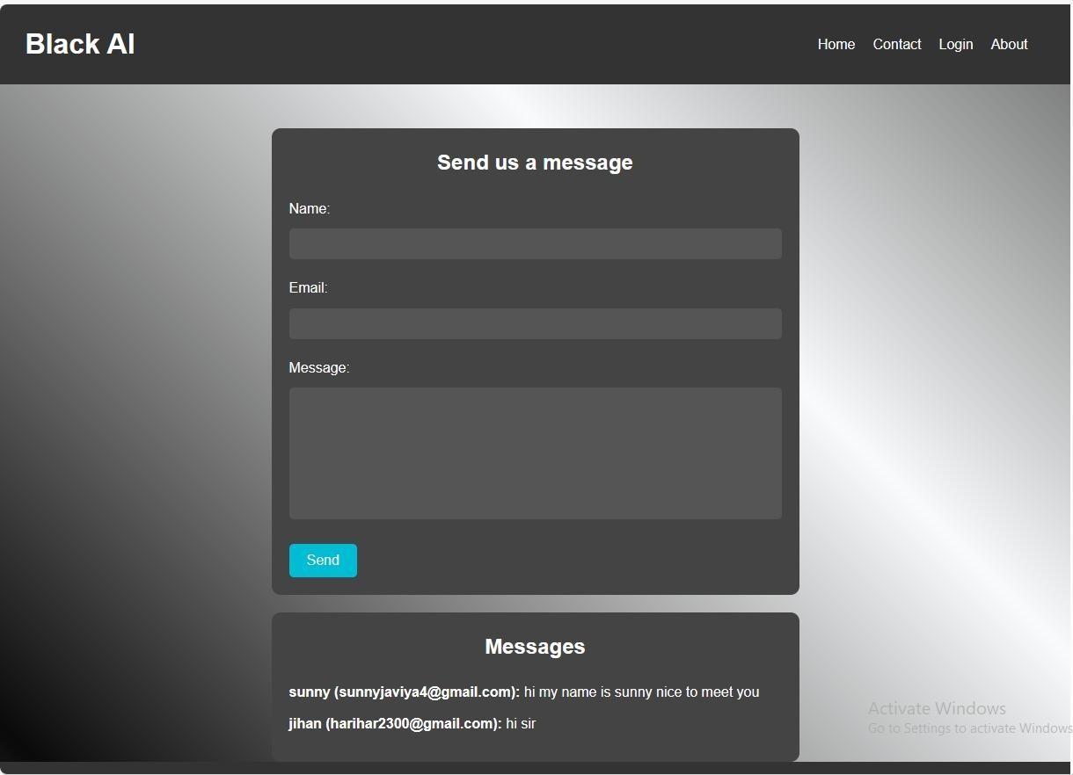

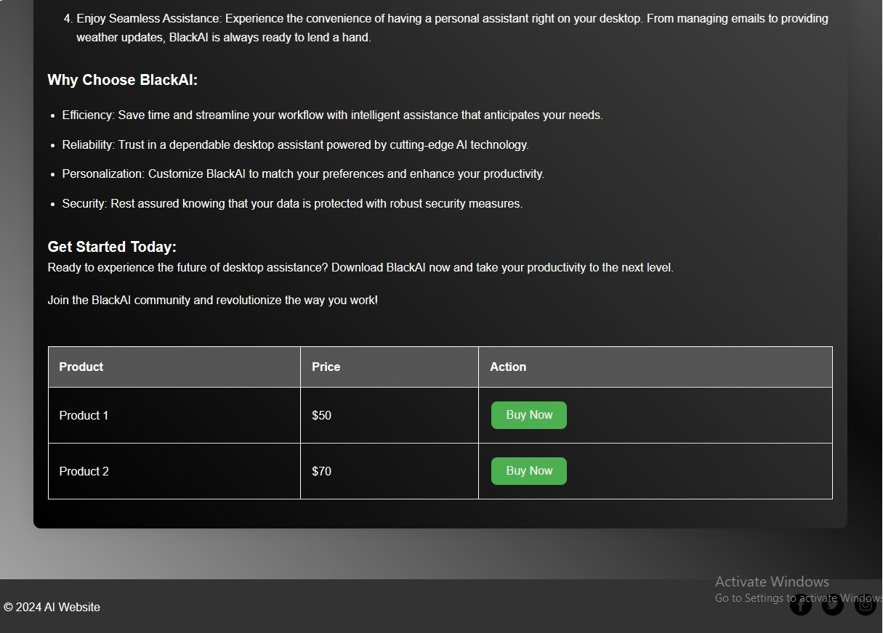

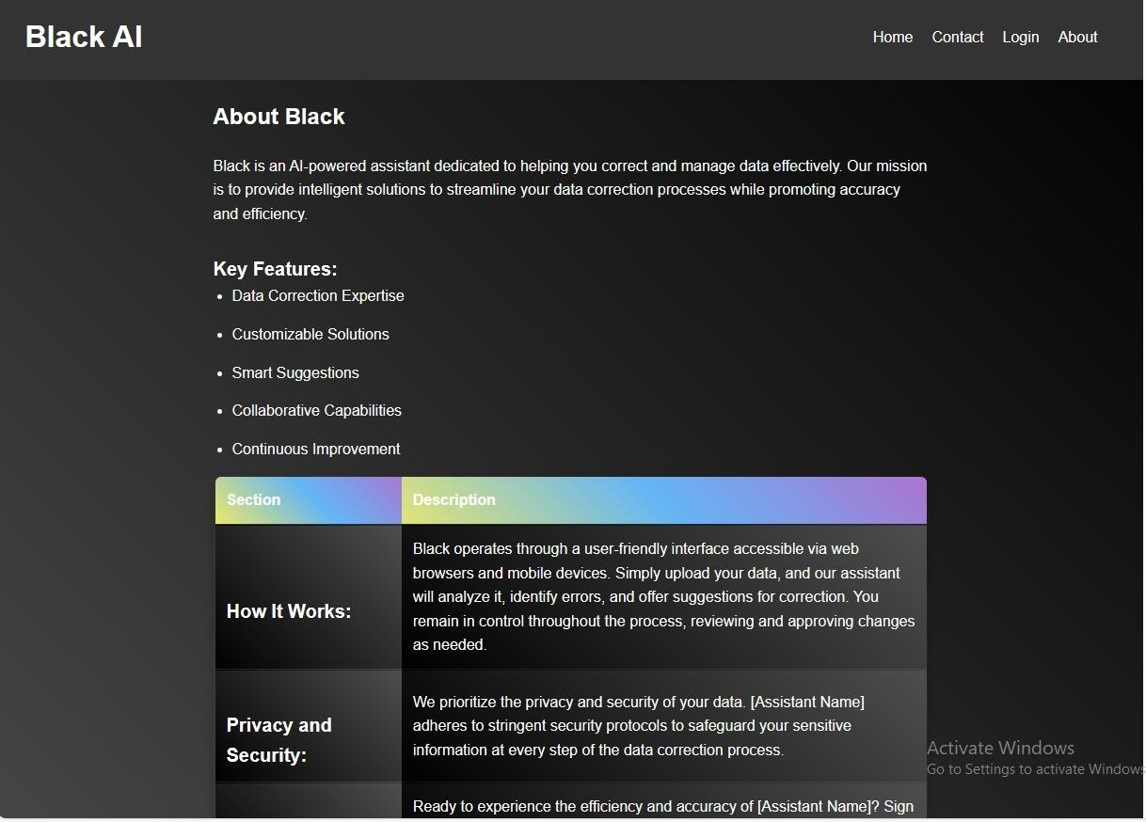

Here's a breakdown of the process:

1. **Setting Up the Development Environment**: Your AI installs Node.js and npm (Node Package Manager) if they are not already installed on your system. These are essential tools for building and managing JavaScript applications, including ReactJS projects.
2. **Creating a New ReactJS Project**: Your AI initializes a new ReactJS project using a command-line interface tool like create-react-app. This sets up the basic project structure and installs all the necessary dependencies for building a React application.
3. **Designing the User Interface**: Using React components, your AI designs the user interface of the website. It creates components for different sections of the website such as the homepage, download page, about page, etc. These components are reusable and modular, making it easy to maintain and update the website in the future.
4. **Implementing Functionality**: Your AI adds functionality to the website, such as handling user interactions, fetching data from a backend server (if required), and implementing features like downloading the software.
5. **Styling and Theming**: Your AI applies styles and themes to the website using CSS, or alternatively, it may utilize popular styling libraries like Bootstrap or Material-UI to achieve a modern and responsive design.
6. **Testing and Debugging**: Your AI ensures that the website functions correctly by testing it across different browsers and devices. It also performs debugging to identify and fix any issues or errors in the code.
7. **Deployment**: Once the website is ready, your AI deploys it to a hosting provider or platform such as Netlify, Vercel, or GitHub Pages, making it accessible to users over the internet.
8. **Maintenance and Updates**: Your AI continues to monitor the website for any issues and performs regular maintenance tasks as needed. It also implements updates and new features to improve the user experience over time.

By creating a ReactJS application for the website, your AI provides users with an intuitive and responsive platform for downloading the software, enhancing accessibility and user engagement.

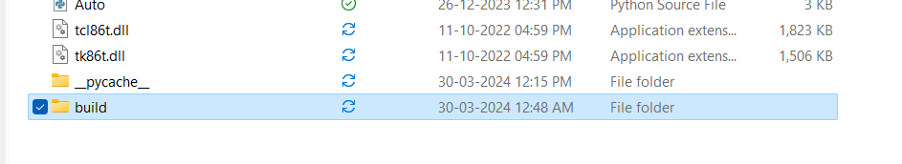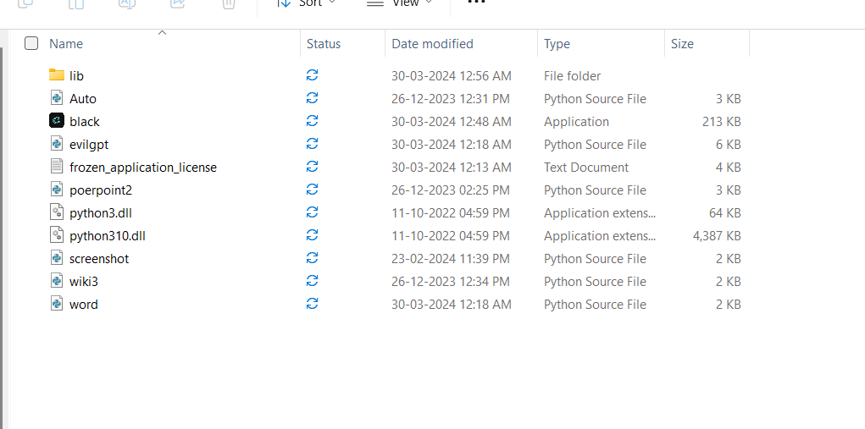

The Tcl/Tk library, commonly referred to as Tkinter in Python, is a versatile and powerful GUI (Graphical User Interface) toolkit. It provides developers with a wide range of tools and functionalities to create cross-platform desktop applications with ease. Tkinter is included as a standard library in Python, making it readily available for developers without the need for additional installations.

Key features of Tkinter include:

1. **Widgets**: Tkinter offers a variety of GUI widgets such as buttons, labels, entry fields, text boxes, and more, allowing developers to create interactive interfaces for their applications.
2. **Layout Management**: Tkinter provides several layout management options, including grid, pack, and place managers, enabling developers to organize and arrange widgets within the application window efficiently.
3. **Event Handling**: Tkinter allows developers to define event-driven behavior for their applications by binding functions to user actions such as button clicks, mouse movements, and keyboard input.
4. **Customization**: Tkinter supports customization of widgets through various options and attributes, allowing developers to tailor the appearance and behavior of their applications to meet specific requirements.
5. **Cross-Platform Compatibility**: Tkinter applications can run on multiple platforms, including Windows, macOS, and Linux, ensuring broad compatibility and reach for developers' software products.
6. **Integration with Python**: Tkinter seamlessly integrates with Python, allowing developers to leverage the full power and flexibility of the Python programming language to build sophisticated GUI applications.

Overall, Tkinter is a robust and user-friendly library that empowers developers to create professional-looking desktop applications with minimal effort. Its simplicity, flexibility, and extensive documentation make it an ideal choice for both beginners and experienced developers alike.

Creating a software application using Tkinter involves several steps:-

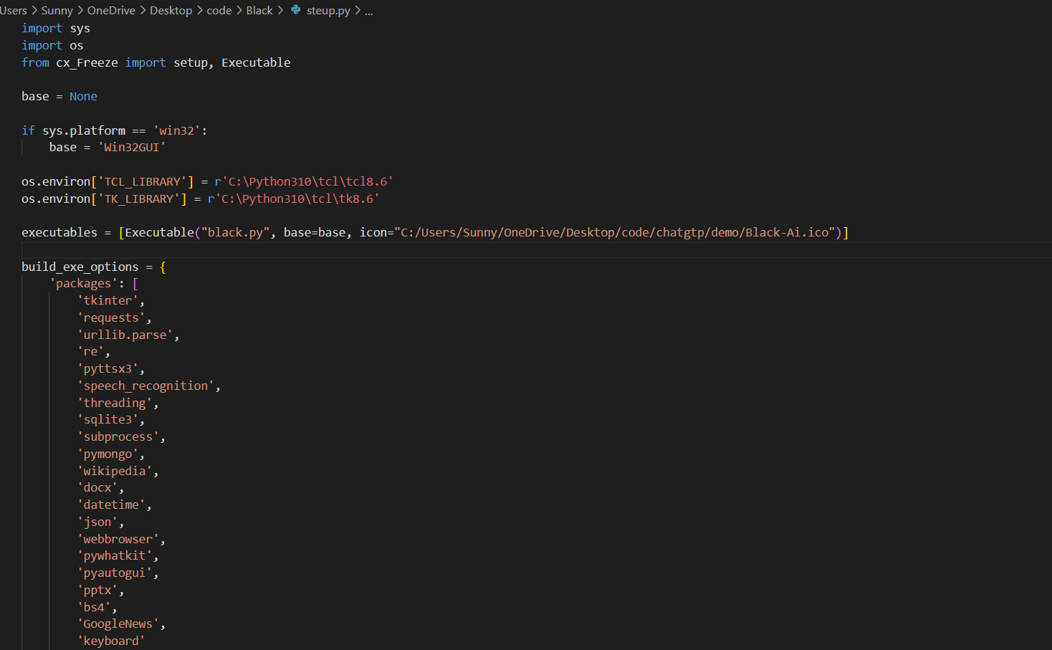

This code is a setup script for creating a standalone executable file for a Voice Assistant application using cx_Freeze, which is a tool for packaging Python programs into executables.

Here's an explanation of the key components of the script:

1. **Imports**: The script imports necessary modules including **sys**, **os**, and **Executable** from **cx_Freeze**.
2. **Base Configuration**: The **base** variable is set to **'Win32GUI'** if the platform is Windows. This ensures that the application runs in GUI mode on Windows.
3. **Environment Variables**: The script sets the **TCL_LIBRARY** and **TK_LIBRARY** environment variables to the paths of the Tcl and Tk libraries respectively. This is required for Tkinter (GUI library) to work properly with cx_Freeze.
4. **Executables**: The **executables** list contains configuration for the executable file. It specifies the Python script (**black.py**) as the main script, sets the base to **'Win32GUI'**, and specifies an icon file (**Black-Ai.ico**) for the executable.
5. **Build Options**: The **build_exe_options** dictionary contains configuration options for building the executable. It specifies the packages, includes, and include files required by the application. Packages such as **tkinter**, **requests**, **pyttsx3**, etc., are listed along with their dependencies.
6. **Setup Configuration**: The **setup()** function configures the setup parameters including the name of the application, build options, version, description, and executables.
7. **Running the Setup**: Finally, the **setup()** function is called with the specified parameters to generate the executable file for the Voice Assistant application.

Overall, this setup script ensures that all required dependencies and files are included in the executable, making it easy to distribute and run the Voice Assistant application on Windows platforms.

The provided script is a setup configuration file written in Python using cx_Freeze, a tool for packaging Python programs into standalone executables. This script is designed to create an executable file for a Voice Assistant application. Here's a full summary of the project:

1. **Purpose**: The project aims to create a standalone executable file for a Voice Assistant application, allowing users to interact with the assistant using voice commands.
2. **Dependencies**: The Voice Assistant application relies on various Python libraries and modules, including Tkinter for the graphical user interface, requests for making HTTP requests, pyttsx3 for text-to-speech conversion, speech_recognition for speech recognition, pymongo for MongoDB database interaction, and several others.
3. **Script Structure**:
   * The script starts by importing necessary modules including sys, os, and Executable from cx_Freeze.
   * It sets the base variable to 'Win32GUI' if the platform is Windows, ensuring GUI mode execution.
   * Environment variables TCL_LIBRARY and TK_LIBRARY are set to the paths of Tcl and Tk libraries respectively, necessary for Tkinter to function correctly.
   * Executables list specifies the main Python script (black.py), sets the base to 'Win32GUI', and specifies an icon file (Black-Ai.ico) for the executable.
   * Build options (build_exe_options) include packages, includes, and include files required by the application, ensuring all dependencies are included in the executable.
   * The setup() function configures the setup parameters, including the name of the application, build options, version, description, and executables.
   * Finally, the setup() function is called to generate the executable file for the Voice Assistant application.
4. **Functionality**: Once built, the executable file will allow users to interact with the Voice Assistant application using voice commands. Users can issue commands, such as asking questions, performing web searches, opening applications, and more, and the assistant will respond accordingly.
5. **Distribution**: The generated executable file can be distributed to users who can then run the Voice Assistant application on their Windows systems without needing to install Python or any dependencies separately.

In summary, the project aims to create a user-friendly Voice Assistant application packaged as a standalone executable file, allowing users to interact with the assistant using voice commands on their Windows systems.

# Software Testing :

The testing process focuses on the logical intervals of the software ensuring that all statements have been tested and so functional interval is conducting tests to uncover errors and ensure that defined input will produce actual results that agree with the required results , Program Level testing , modules level testing integrated and carried out .

## Unit Testing

* **Test Case for User Login**

|  |  |  |  |  |
| --- | --- | --- | --- | --- |
| **Testi d** | **TestFiled** | **StepExec uted** | **ExpectedResult** | **Actual Result** |
| 1 | User Name | Empty or Wrong | Wrong user name or password | AsExpected |
| 2 | Password | Empty or Wrong | Wrong user name or password | AsExpected |

* **TestCasefor Add member**

|  |  |  |  |  |
| --- | --- | --- | --- | --- |
| **Test id** | **Test Filed** | **Step Executed** | **Expected Result** | **Actual Result** |
| 1 | UserName | Empty or Wrong | Msg.‘enterfullname’ | AsExpected |
| 2 | Email | Empty or Wrong | Msg. ‘please enter valid email address email is required | AsExpected |
| 3 | Password | Empty or Wrong | Msg “Password is required orwrong password” | AsExpected |

* **TestCasefor Delete member**

|  |  |  |  |  |
| --- | --- | --- | --- | --- |
| **Test id** | **TestFiled** | **StepEx ecuted** | **ExpectedResult** | **Actual Result** |
| 1 | Delete Account | OnPress ing | Alert Box to confirm to deleteaccount. | As Expected |

# References :

1. **AI Fairness 360 (AIF360) by IBM:**
   * GitHub Repository: [AI Fairness 360](https://github.com/IBM/AIF360)
2. **Fairlearn Toolkit by Microsoft:**
   * GitHub Repository: [Fairlearn Toolkit](https://github.com/fairlearn/fairlearn)
3. **TensorFlow Model Garden:**
   * GitHub Repository: [TensorFlow Model Garden](https://github.com/tensorflow/models)
4. **Kaggle Datasets and Notebooks:**
   * Website: Kaggle - Search for datasets and AI projects related to fairness, ethics, and bias.
5. **Google AI Blog:**
   * Website: Google AI Blog - Explore articles and projects related to AI research and development.

|  |  |  |  |
| --- | --- | --- | --- |
| **Project Summary**  The "Black AI Assistant" project aims to develop an intelligent virtual assistant using Python, React, 3D CSS, and JSON technologies. The assistant will offer voice recognition, natural language processing, and task execution capabilities through an interactive graphical user interface (GUI). By leveraging the power of these technologies, the project seeks to enhance user productivity and convenience while providing an engaging and visually appealing user experience.  Key Components: | | | |
|  | 1. | **Python Backend** | : Utilized for backend development, including natural language |
| processing and task execution functionalities.   1. **React GUI**: Employed to build an interactive and visually appealing graphical user interface for the assistant. 2. **3D CSS**: Integrated to enhance the visual experience of the GUI, providing users with engaging 3D elements. 3. **JSON Data Management**: Used for storing and managing data required by the   assistant, ensuring efficient access and retrieval. | | |
| Objectives Achieved: | | | |
|  | * Development of a functional black AI assistant capable of voice recognition and natural language understanding. * Implementation of an intuitive GUI using React and 3D CSS, providing users with an interactive platform for interaction. * Integration of JSON for efficient data storage and management, ensuring seamless access to relevant information. | | |
| Future Directions: | | | |
|  | * Enhancing natural language processing capabilities for improved understanding and response. * Integration with IoT devices for home automation and expanded functionality. * Support for additional languages and dialects to cater to a wider user base. * Continuous learning and improvement through machine learning algorithms for personalized user experiences. | | |